**UiPath Activity Coverage | How UiPath Test Activity Coverage Works**

Before this, you can refer Test explorer in Exam 3 page

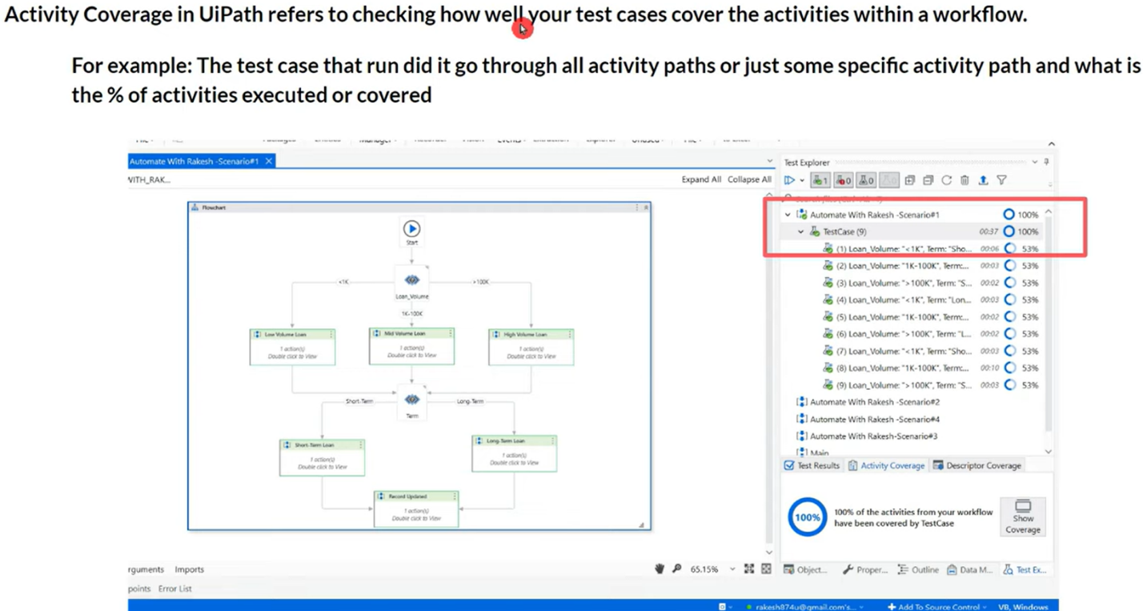

Build a similar automation like below in your uipath studio to check all the decisions & activity coverage. Let's consider this excel.

Depending upon when this amount is going to be paid, it will be considered as short or long term.

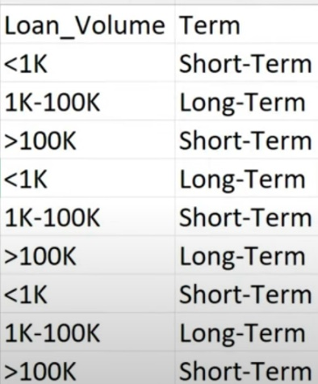

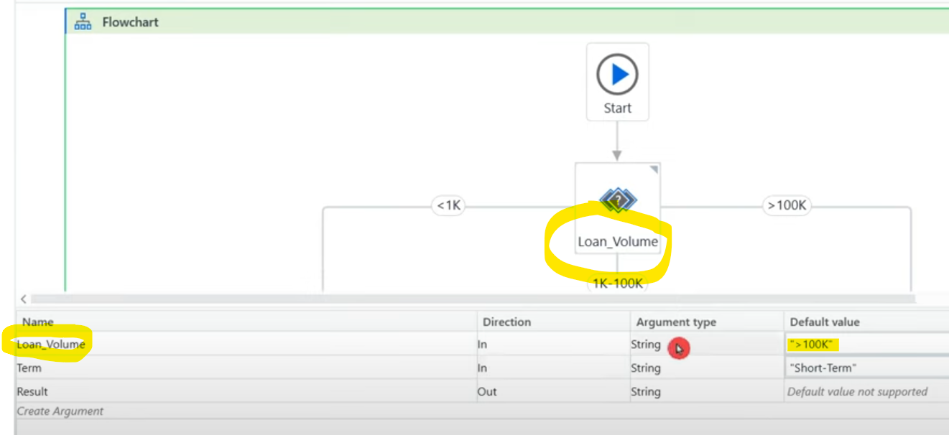

Execution takes 3 different paths based on the condition given in those flows.

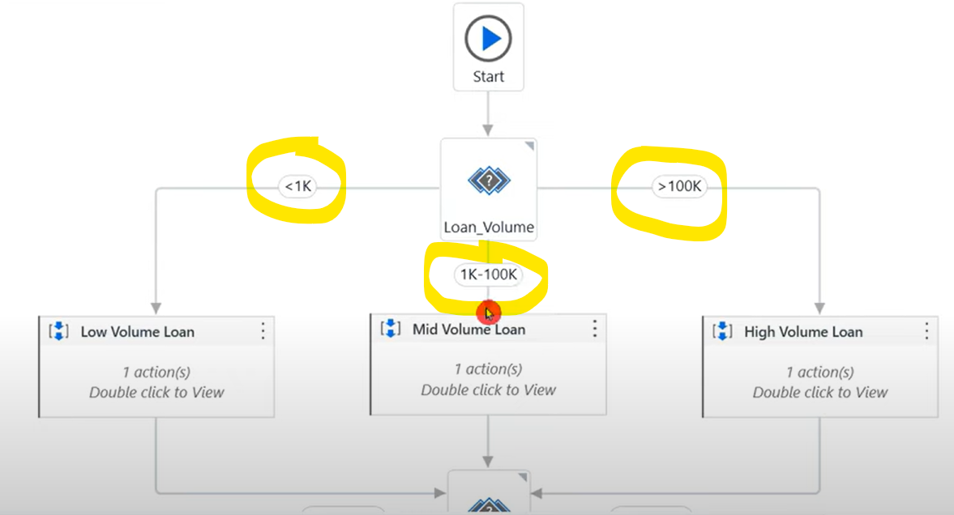

Similar log messages are present in other 2 sequences of mid & long term.

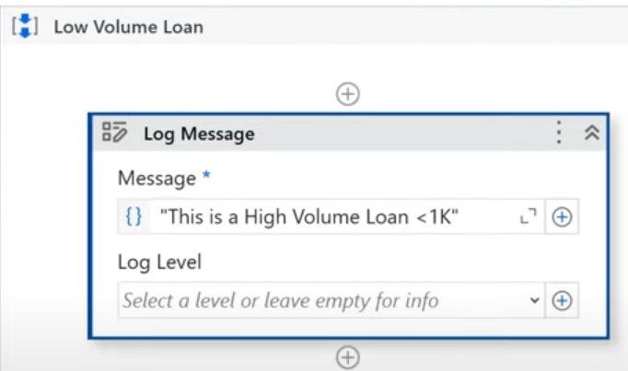

Again there is a flow switch activity used like below.

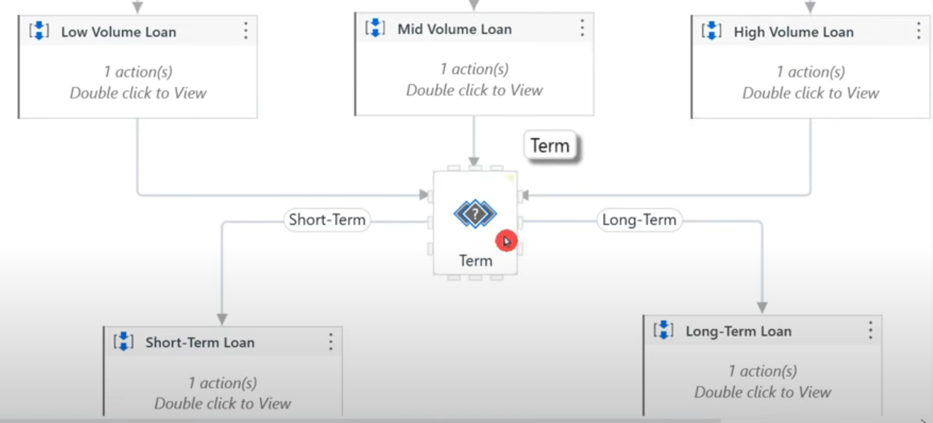

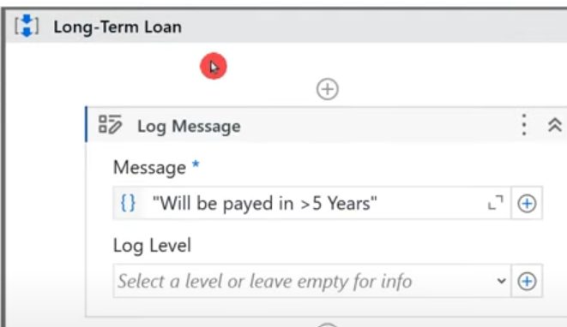

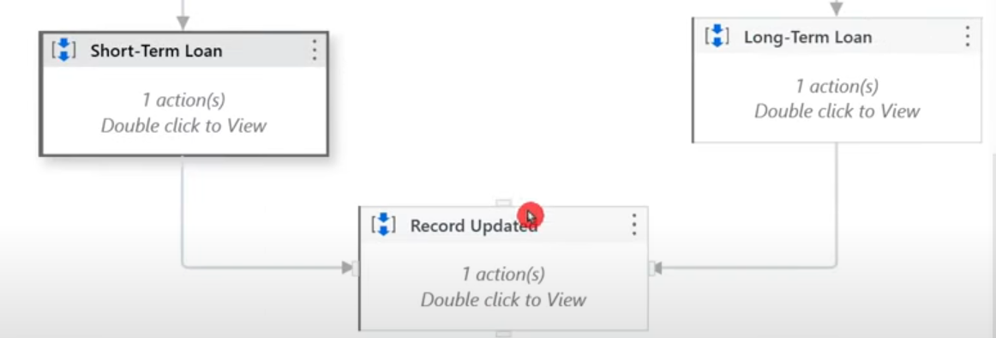

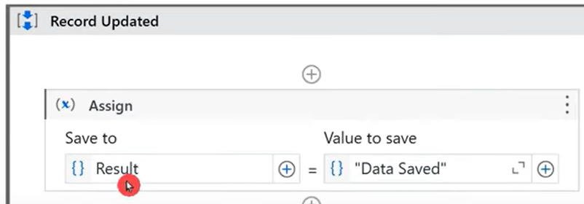

Keep the arguments blank. This workflow will run only if we pass values. Result is output argument which sends the value out.

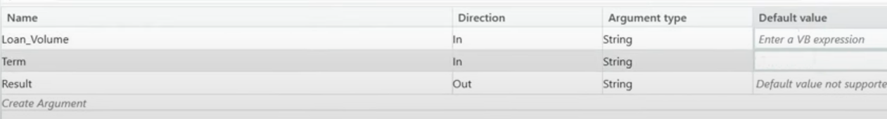

This is the code in studio, let's see how to create test case for this. Right click on the xaml & create test case.

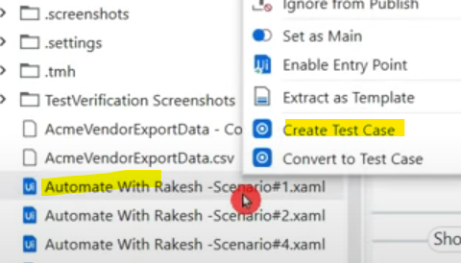

Im not going to select any test data at the moment.

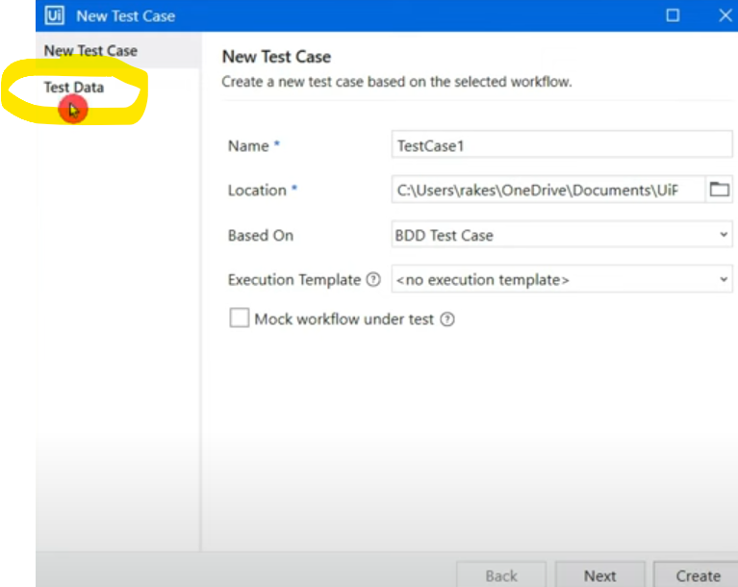

All the arguments created in xaml file, will reflect in test case below.

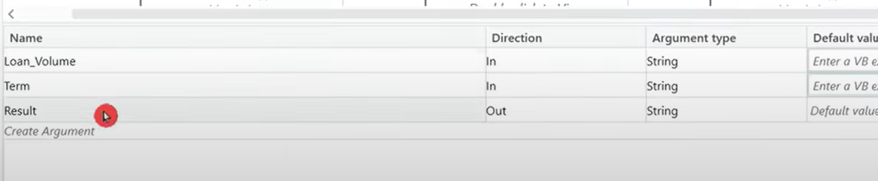

Above arguments are here in test case arguments.

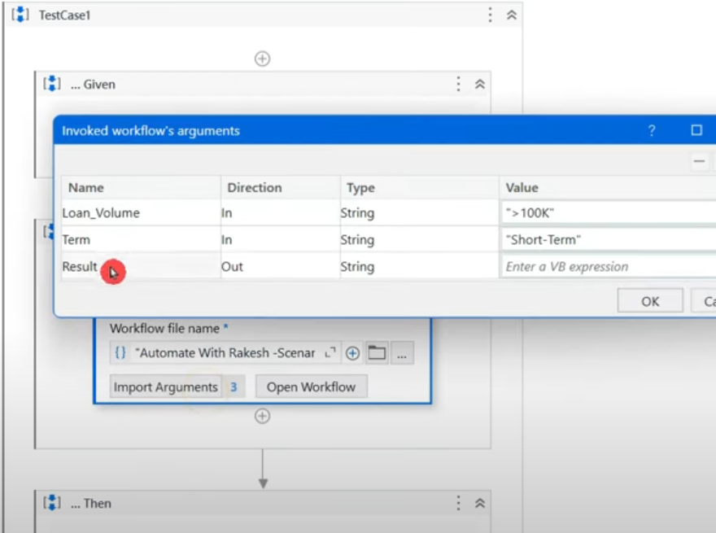

Keep the above values empty & assign variables later. Use multiple assign activity above WHEN section & update like below.

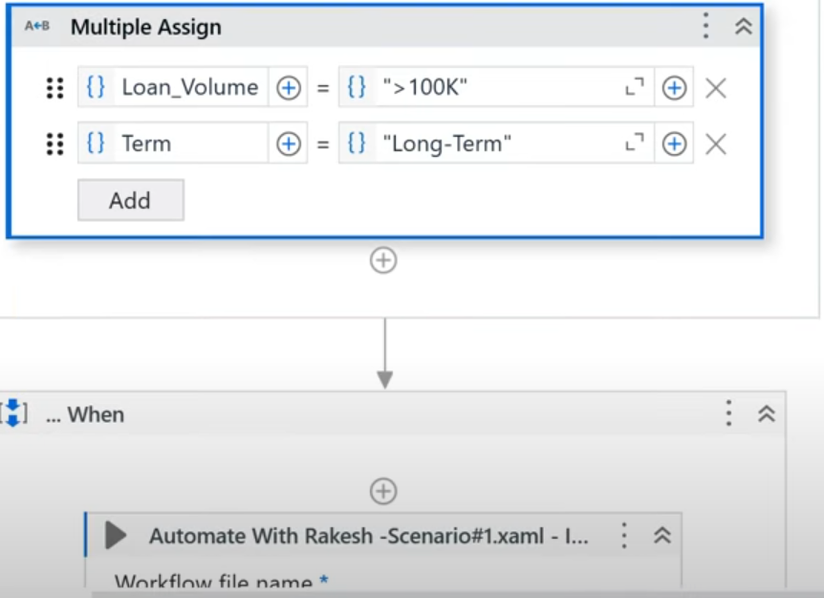

Pass the above variables here.

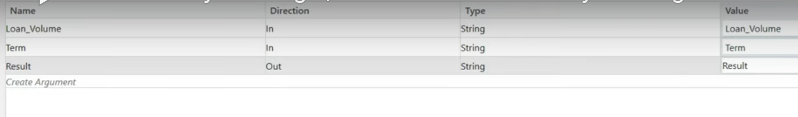

Use the below in THEN section which means for all the excel inputs passed, it should go through its respective paths in code & finally reach this Data saved sequence in code.

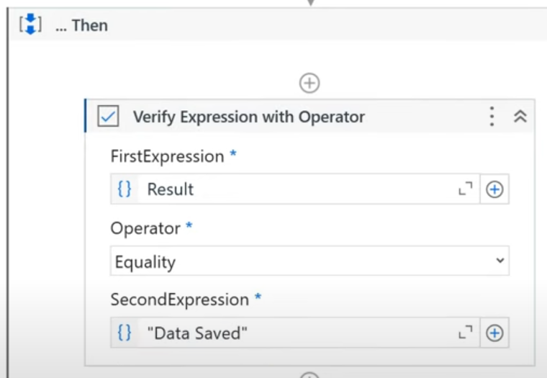

First we'll see the output.

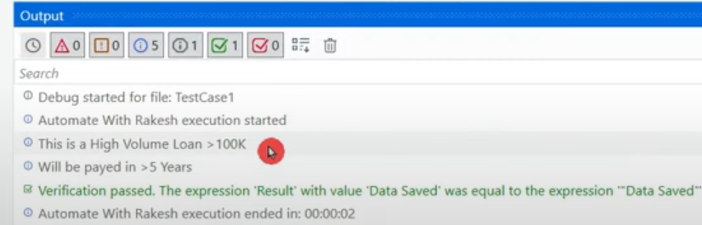

If you see the "Test explorer", the previous run with inputs has executed/covered only 53% of the activities in the code.

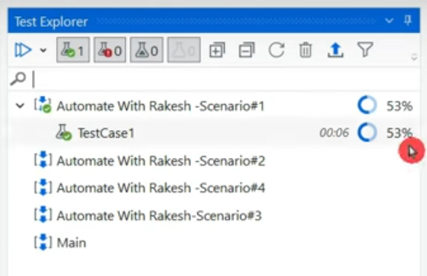

If you click on the test case, below you will see activity coverage of that test case & you can click on "Show coverage" to see the activity % executed for that test case.

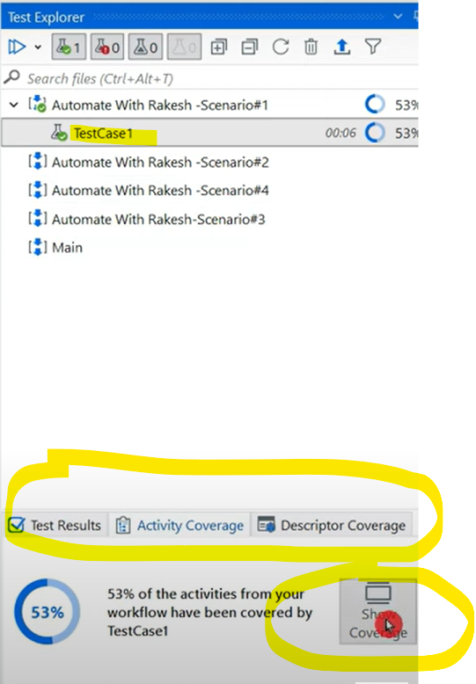

The sequences executed will be covered in green like below.

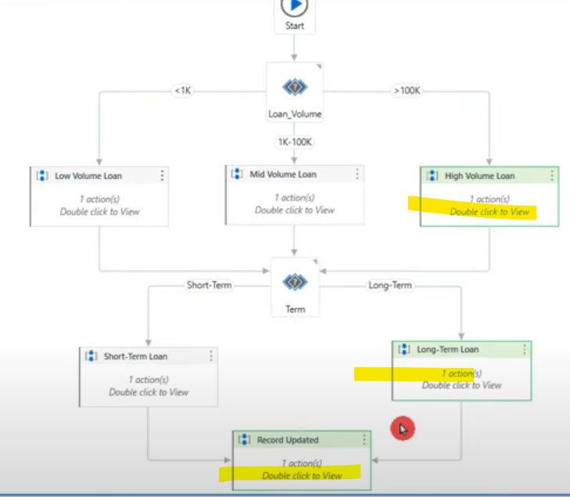

**Through this we get to know, we have tested only this much of the workflow (partial coverage).**

How do I test all the sequences with all the data? Right click on Test case & "Add Test Data".

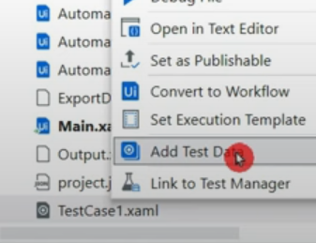

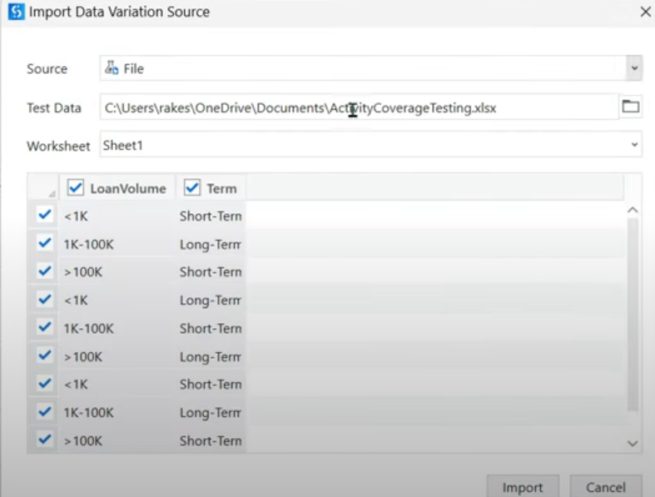

If you get the below error, you need to remove the values you assigned to the test case previously.

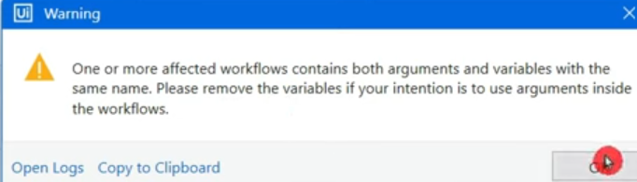

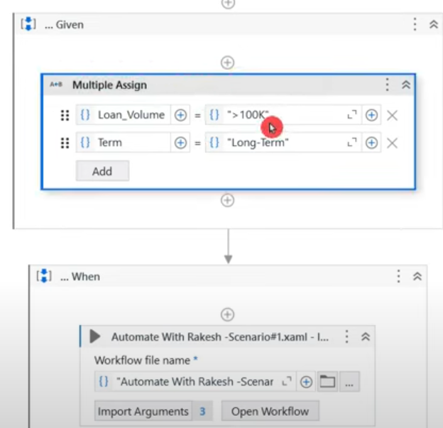

Also these variables inside the test case must be deleted.

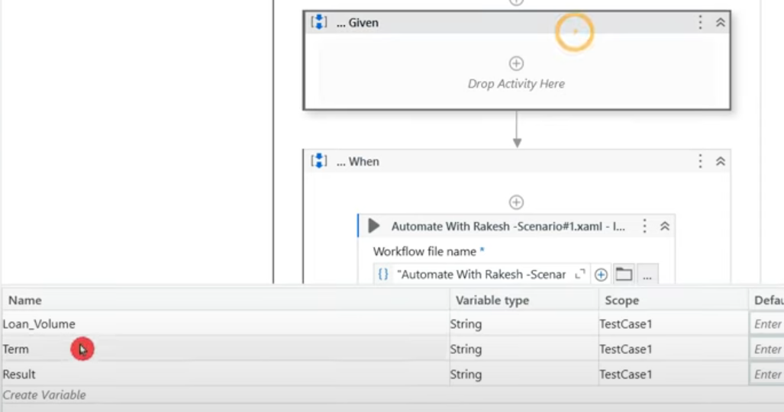

The below mapping anyways happen automatically with the use of test data you uploaded.

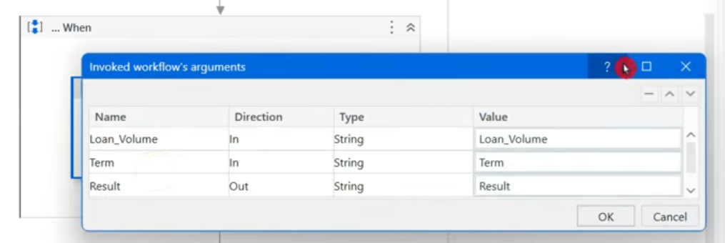

There are 9 different test data as you can see in the below snap in "Test Explorer" under your test case. It is showing all the test data rows.

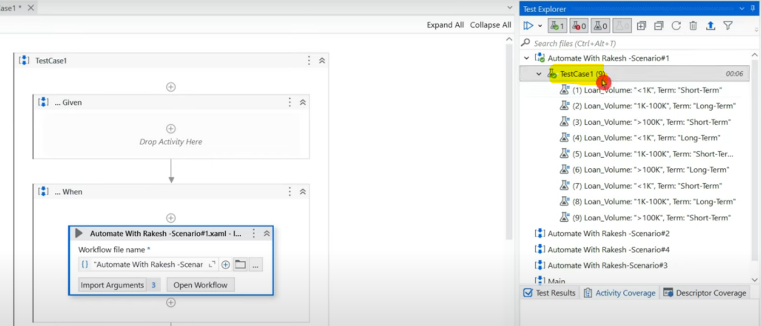

To run all these, click on "Run file with data variations"

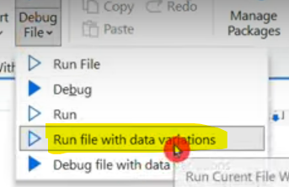

It allows you to select data, select all of them & click on Run.

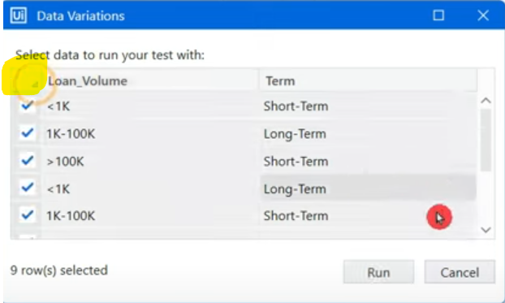

Now all the 9 cases will be covered one by one. For different data, it is taking different paths in the code. Now we can see 100% coverage for test case.

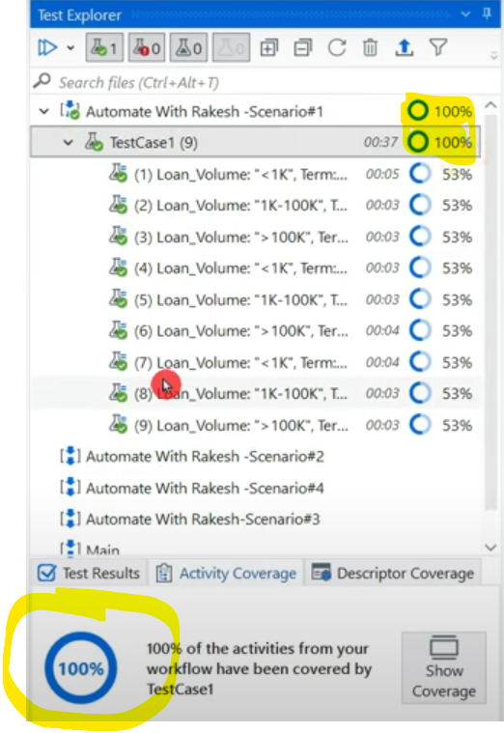

If you click on "Show coverage" option above, we can see all the sequences turned green indicating they have been run which means the code is tested for all the possibilities built.

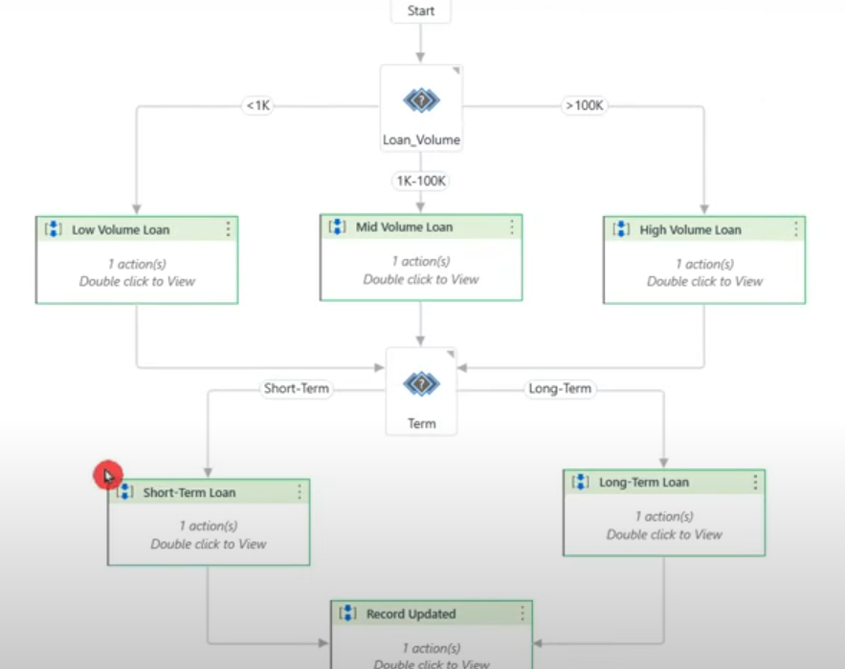

If you click on particular test data & click "Show coverage", it shows the path it was executed.

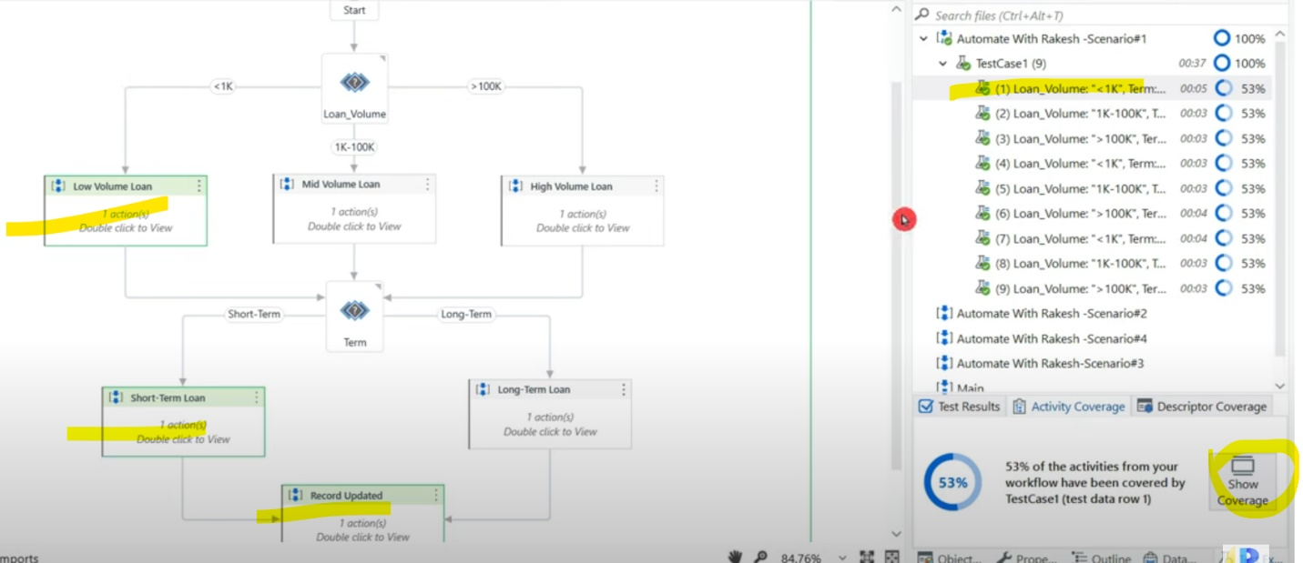

=================================================================================================================================

=================================================================================================================================

**Mock Testing**

Mocking means acting/mimicking someone.

1. Here we have 2 parts - download & upload elsewhere. The main function is to test the flow & see if UPLOAD is happening for which no need to download the file again & again. You are trying to mimic some part of workflow & also save time.
2. Suppose application goes down and now you will face challenge to download data & then upload it.

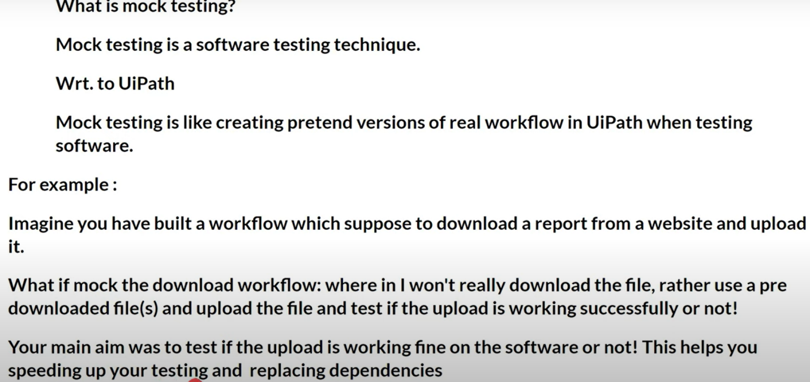

To download the report,

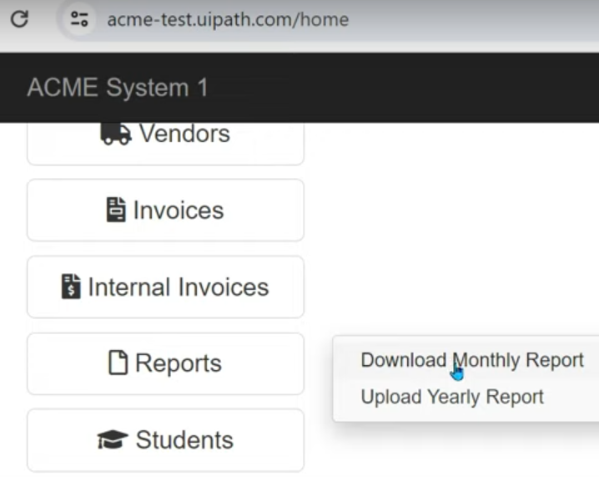

Below are the list of vendor IDs to be used for demo.

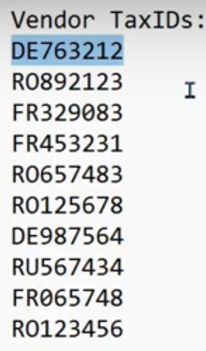

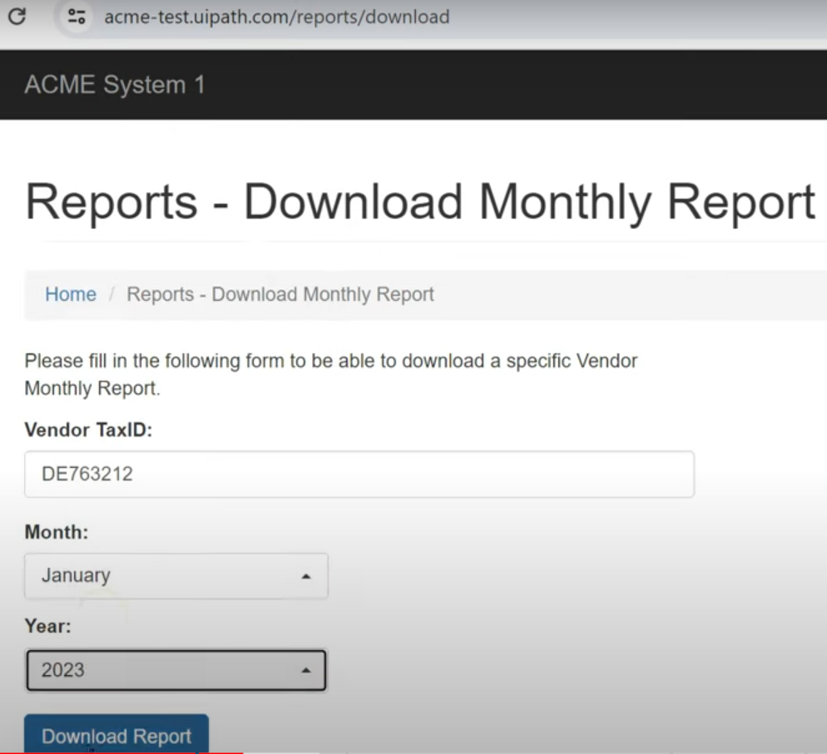

This report will have some sample data.

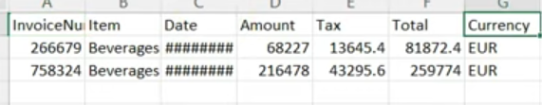

Once downloading is complete, go to upload option.

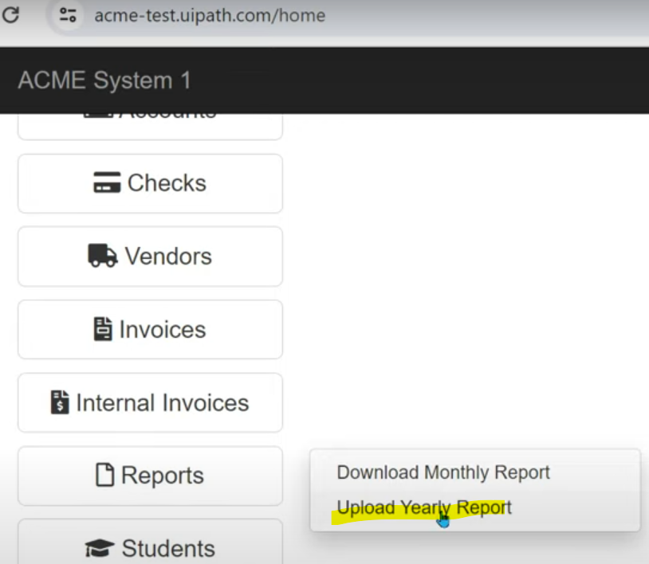

Enter the same vendor ID & year & choose the downloaded file & upload it.

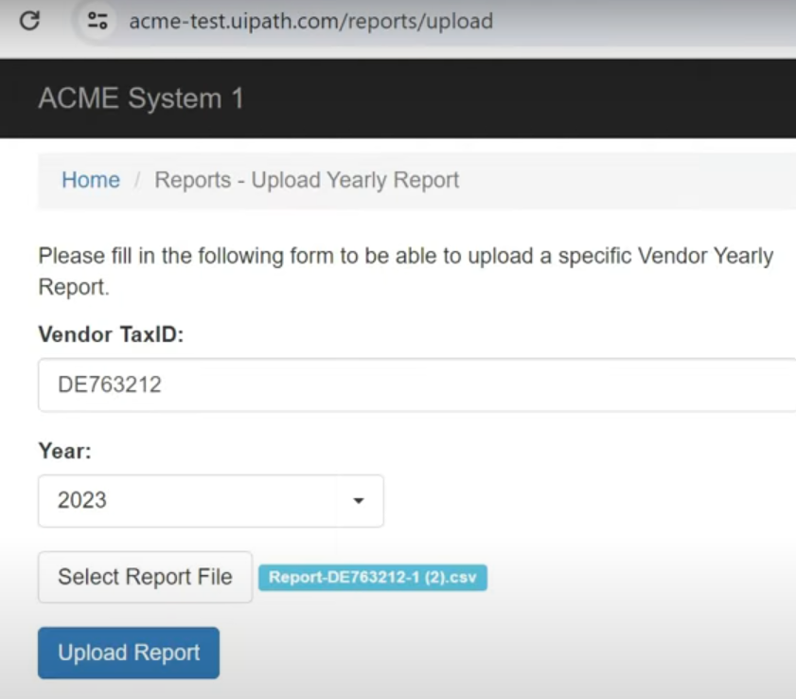

Only after the below pop we can get confirmation that file was uploaded.

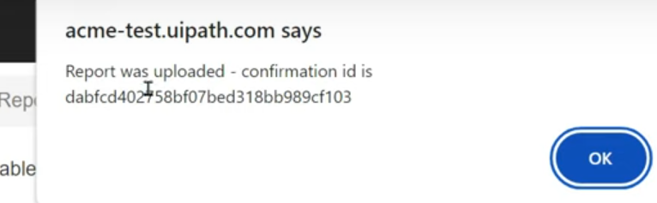

2 xamls are created, one for download and another for upload.

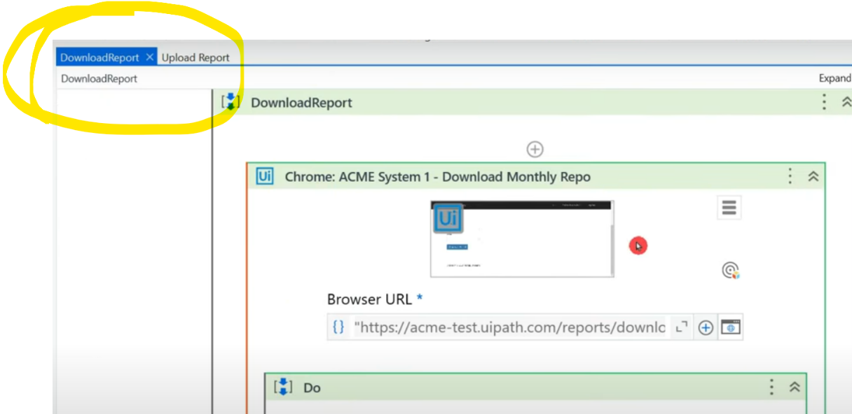

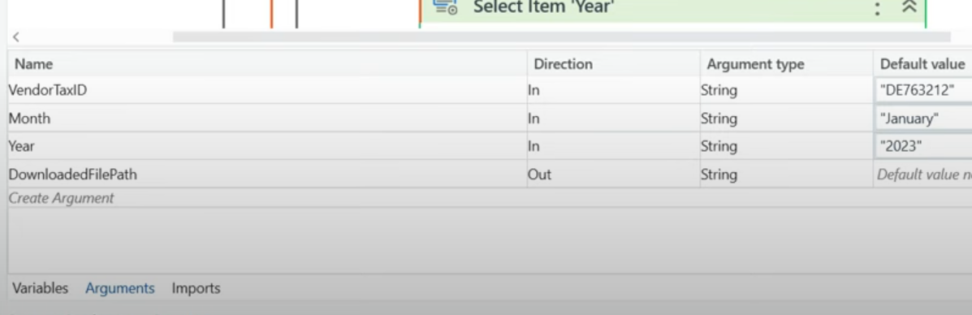

Once the downloading is done, I'm using assign activity to set download path.

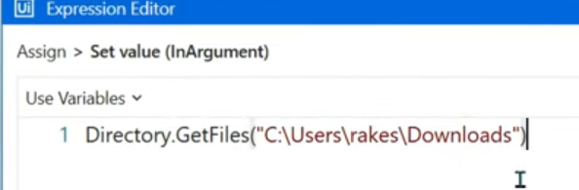

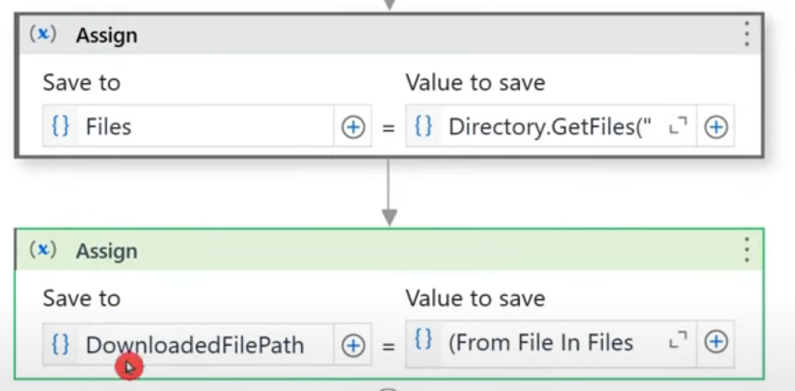

DownloadedFilePath argument has a linq query in it's value.

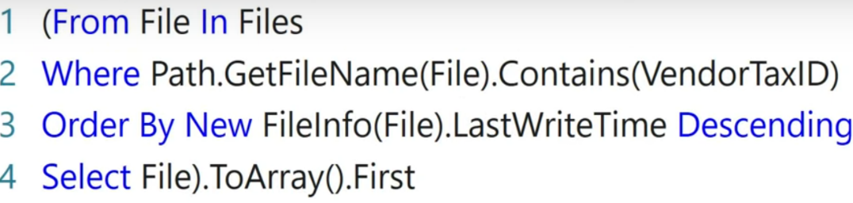

NOTE: As there will be many files in the folder, it filters based on the vendor Tax ID in the file name & then to this collection of filtered files, it applies another filter where it is ordered in descending order of the last write time so the recent file gets selected in the top & then that file is picked as .First.

Now I have a main sequence where I have invoked these 2 xamls.

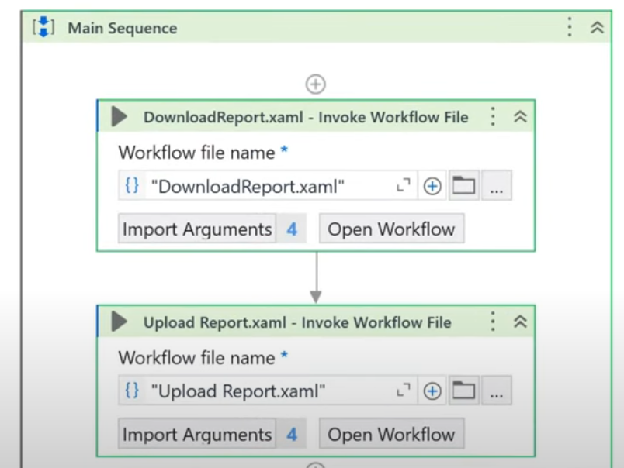

To create a mock test of this, right click on main xaml & create test case & check the mock option.

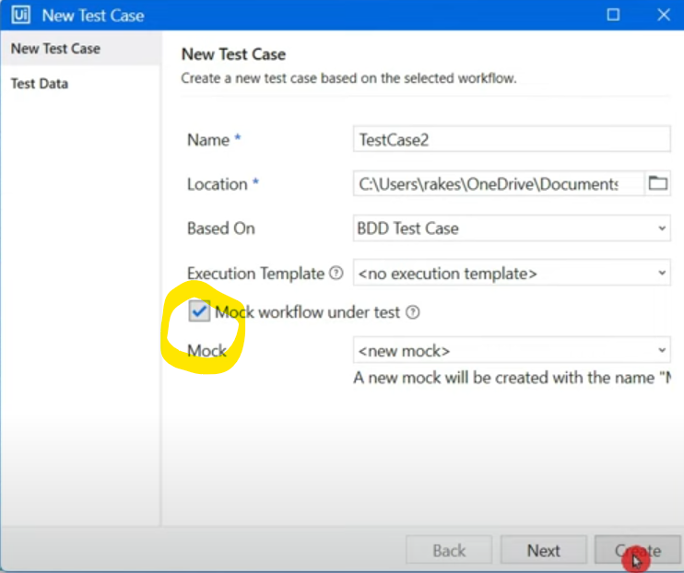

Also pass the test data, below is the test data.

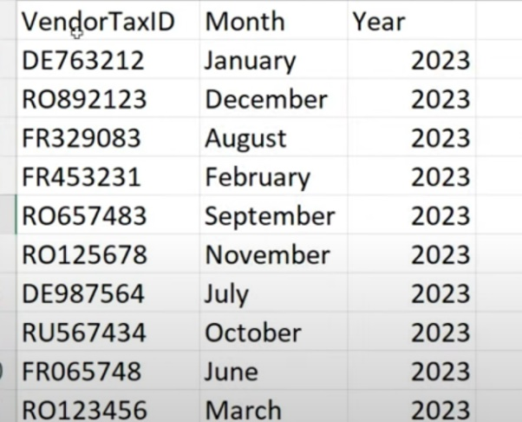

Now we have created a test case & also a mock test case.

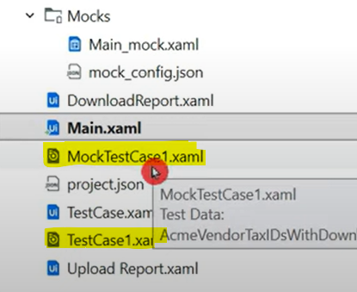

Let's run the test case. It took about 34 seconds for 1 data row. How much time savings this can do? Let's see how mock testing can save this time.

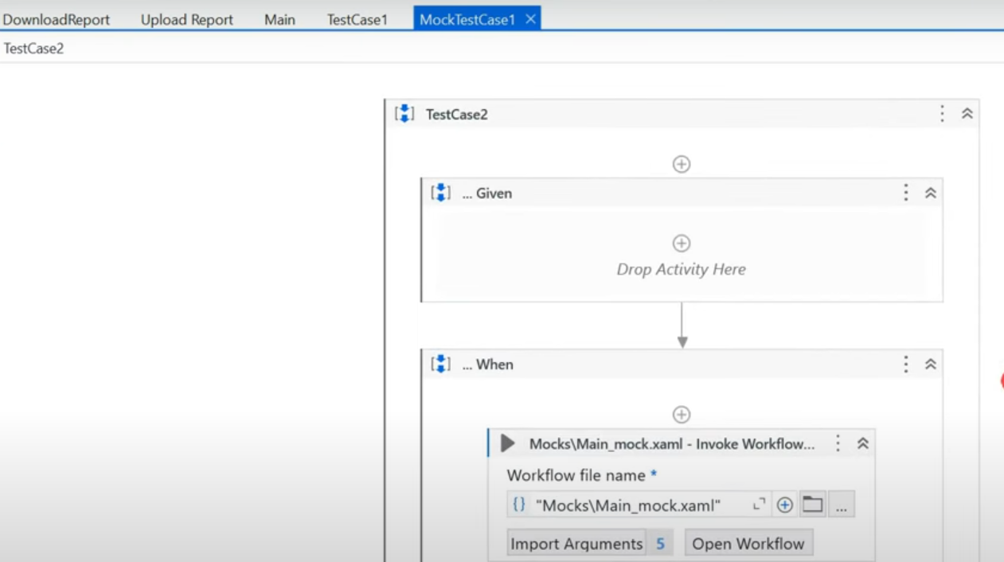

Mock testing looks exactly like Test case but the difference is the test case name. Only different thing is there is a mock activity, right click & select "Remove mock activity".

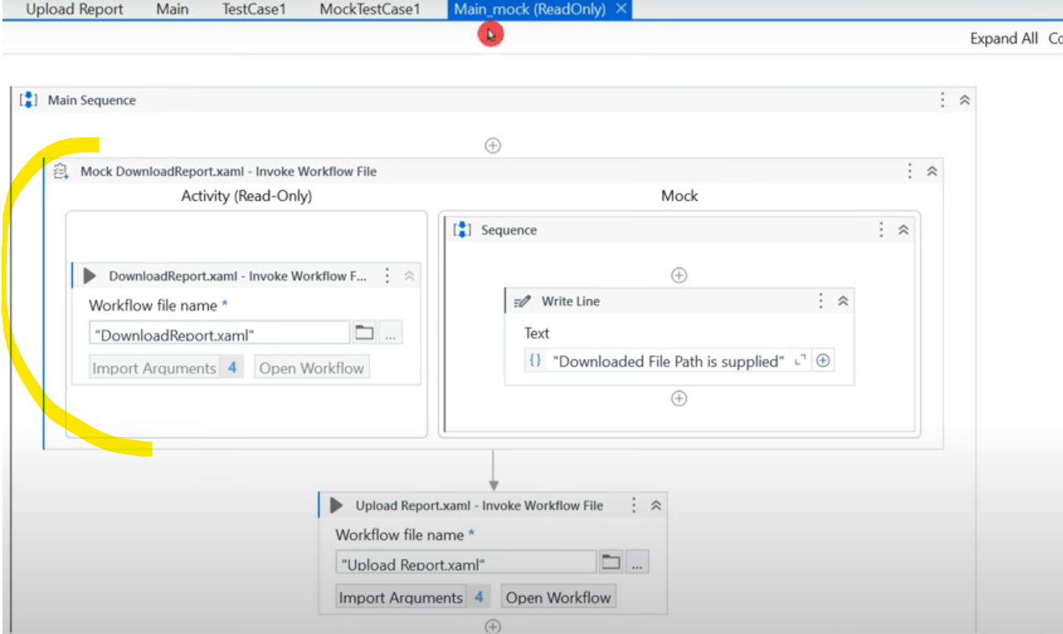

Now we get only 2 xamls we created and let's mock "Download" xaml. Right click & select "Surround with mock".

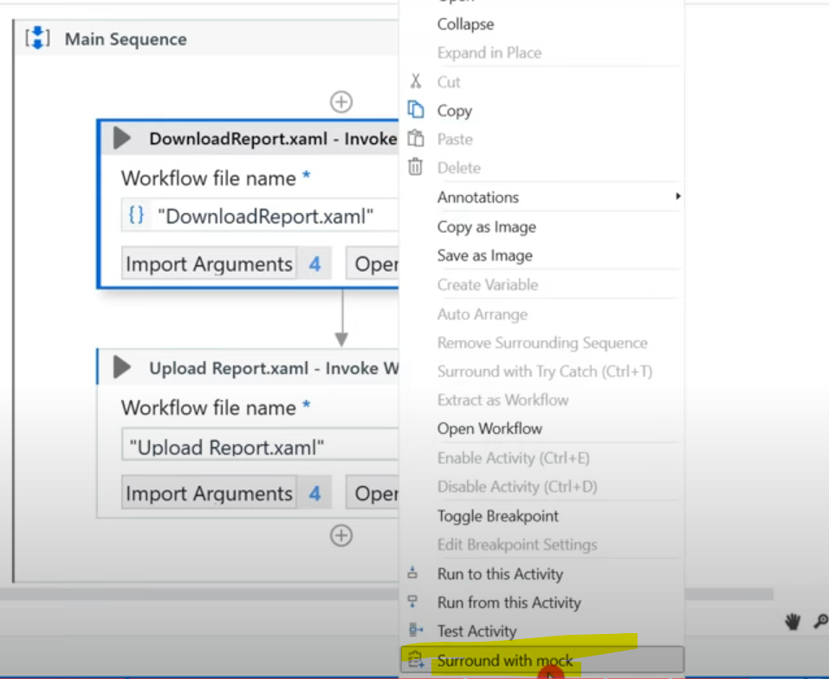

When you do this, you are skipping as you do not want to download it as it is already downloaded & stored somewhere. So this part becomes "READ ONLY" & it is not executed. The right part will be executed. Let's include write line activity.

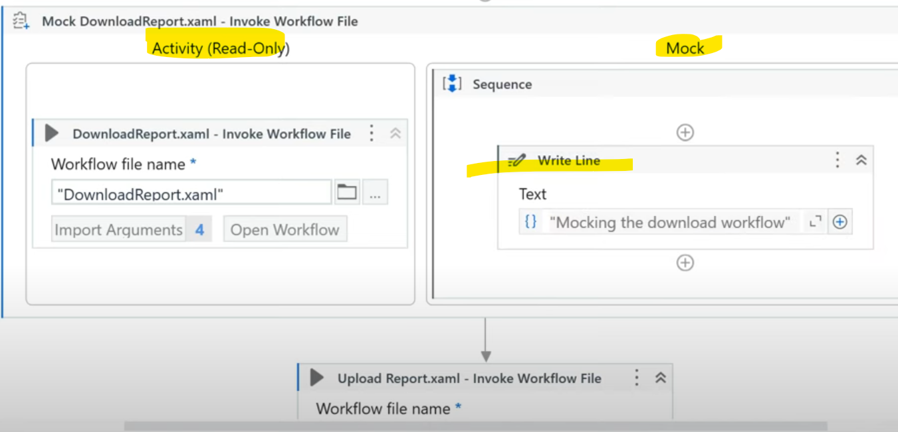

Question is how to mock it? We will make a slight change in "Upload" xaml argument section.

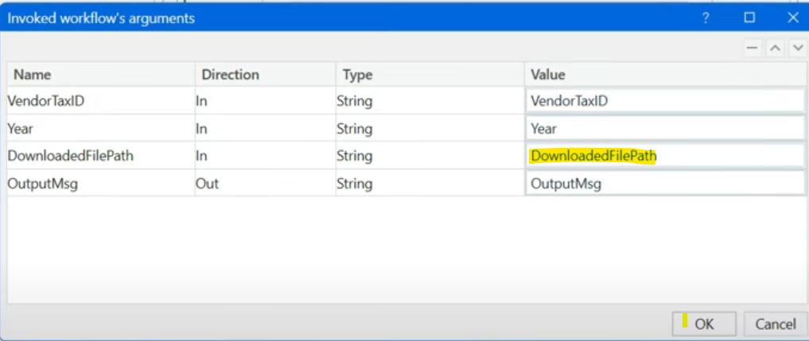

This DownloadedFilePath will not come from the above xaml "Download" instead we will prepare another input file for mocking purpose adding it's file path.

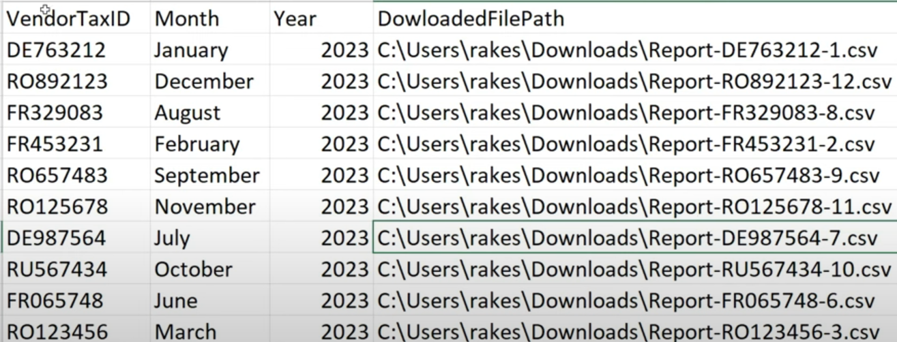

If you hit on "Run file with Data variations", it shows up all the data before running. Let's select 1/2/3/all & run.

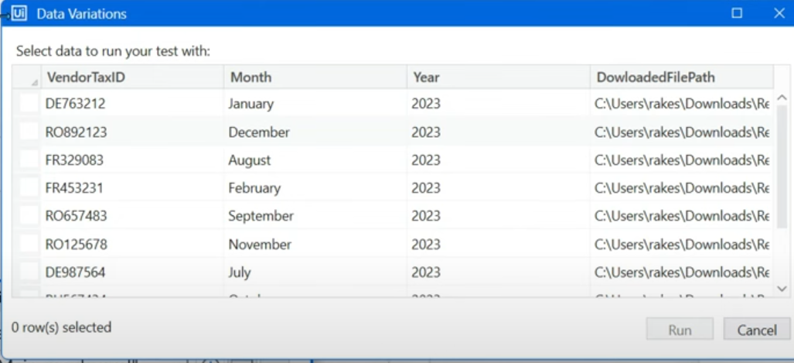

Now, while running, it directly went to Upload browser link. Total time taken here is 24 seconds.

Initial one took around 34 seconds for 1 data, when we run 10 data it takes 340 seconds. The same with mock testing saves 100 seconds. Imagine in case of 1000s of data to be tested in a workflow.

=================================================================================================================================

**Publishing Test Cases to UiPath Orchestrator:**

*NOTE:*

1. Select test case -> Set as publishable.
2. Publish test case from studio to orchestrator.

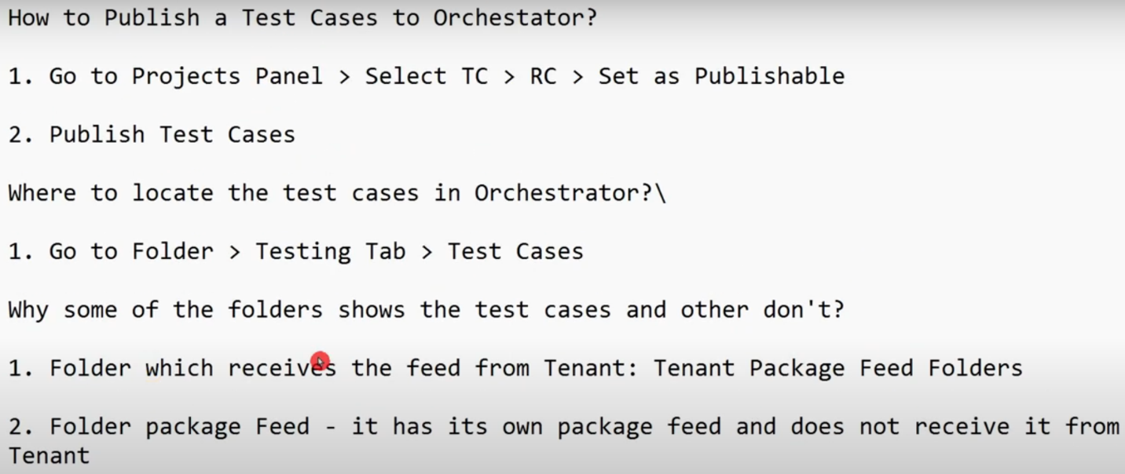

Using control button, select the required test cases & it gets highlighted, then right click & select "Select as Publishable"

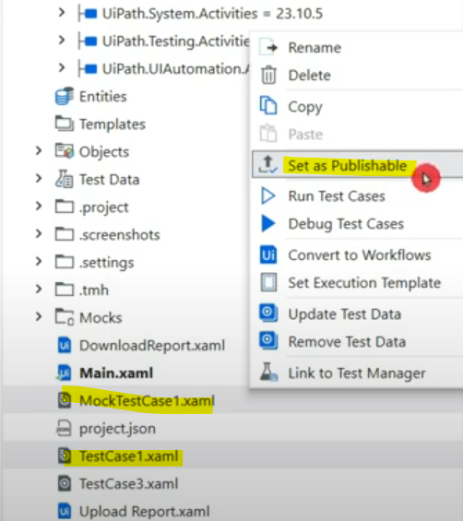

The moment I did this, color of test cases changed from grey->blue.

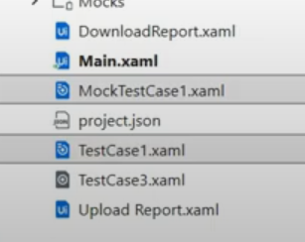

Now publish from design bar by selecting **DROP DOWN**

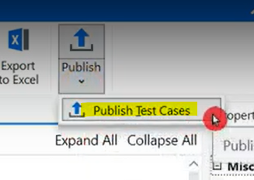

The window should say "Publish Test case" not processes, like below, give preferred name, click next, next & publish.

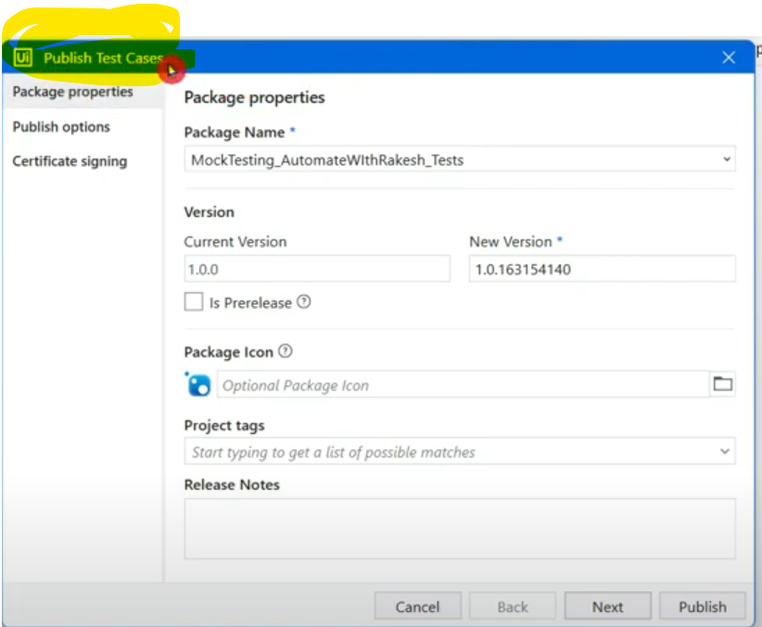

If you directly select Publish button, it will publish process as below & not the test cases.

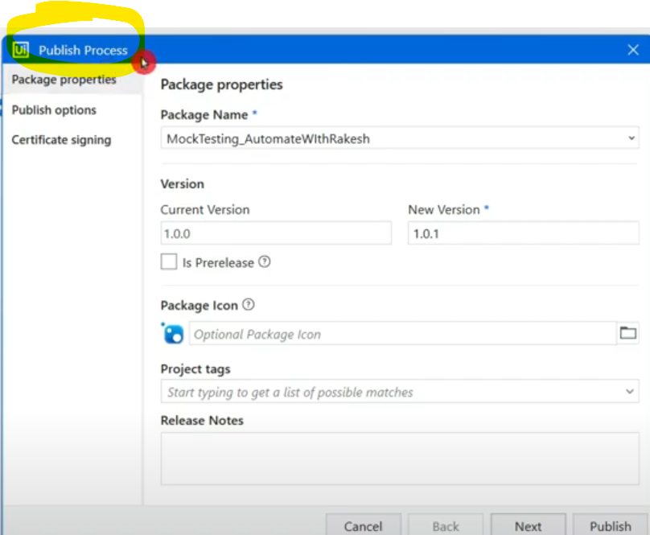

Where to locate this test case in orchestrator now?

If we look at tenant level, we don’t find test case tabs anywhere.

If you check at folder level, there is a tab called "Testing".

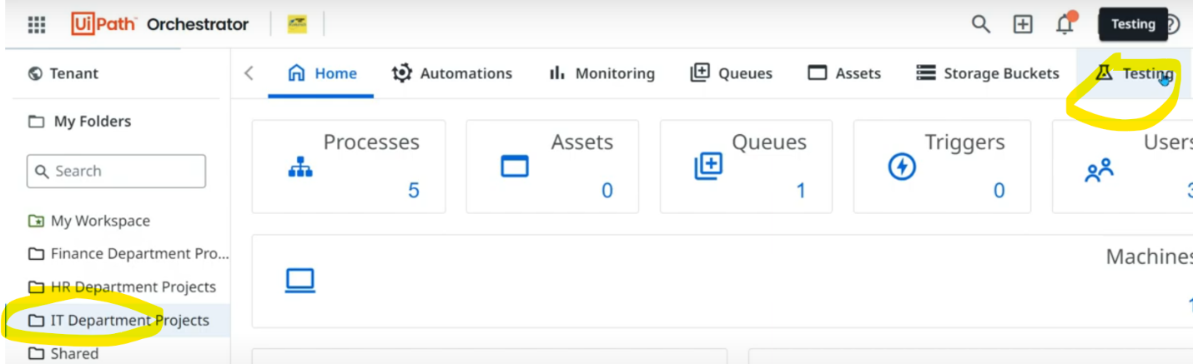

At FOLDER level, inside Testing tab, we can see Test cases tab where we will see what we published.

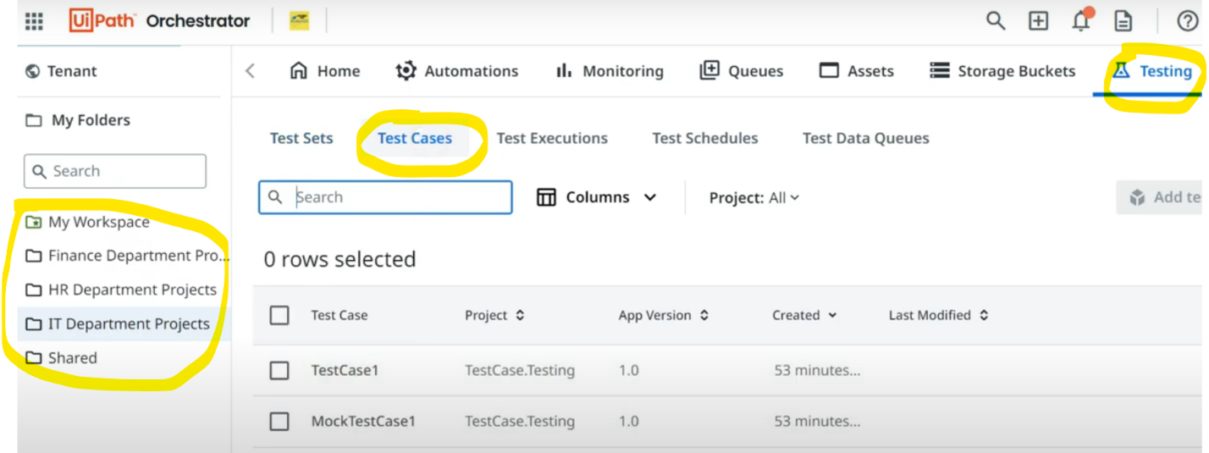

We can see the test cases under "IT Dept" & "Shared" folders only & not able to see under other 2 folders. Why?

When we create folders, we see 2 different options in below 2nd snap.

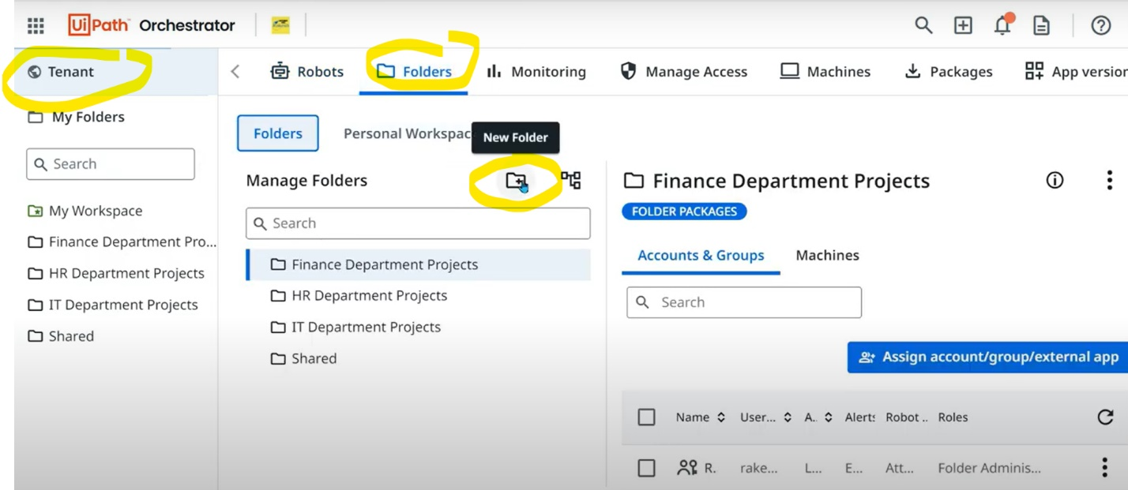

* **Tenant package feed:** Folders which receives the feeds from tenant. Means uploading anything to orchestrator feeds.

While publishing it asked options & we have choose orchestrator tenant processed feed (the 1st one). Because of this, folders that are created with option "Tenant package feed" (in below 2nd snap) will receive these test cases.

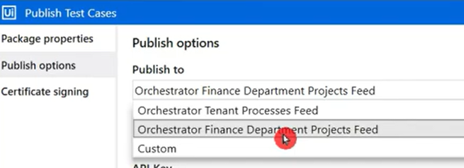

* **Create a new package feed to this folder:** Other 2 folders in our orchestrator are created using this option. Has its own package feed & doesn't receive from Tenant.

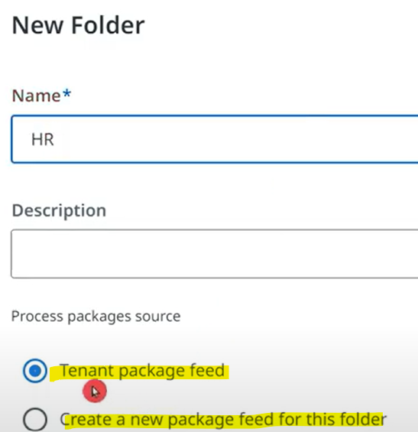

Let's say, we want those 2 folders which are not created under "Tenant package feed" to have our test case reflecting under it.

Go to studio & refresh the folders & select the one you want (created under its own feed package & not the tenant one).

If you do not do this step then this folder will not get reflected in the publish test case option in studio.

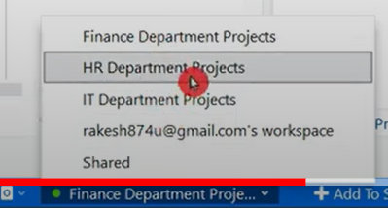

After doing the above, let's publish test case from studio.

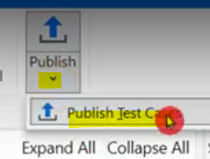

Once above step is done, we can choose the folder from below popup & publish.

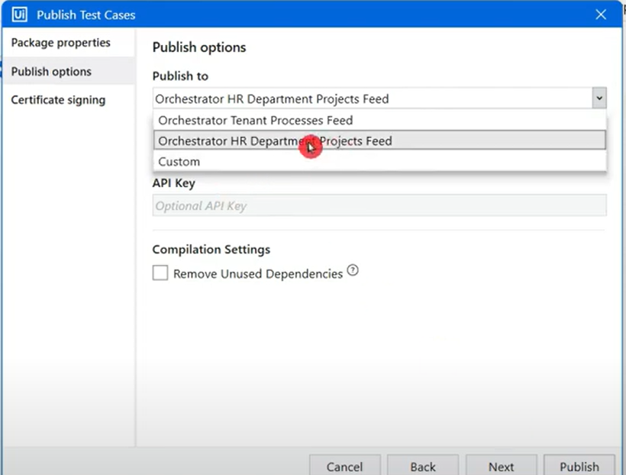

Now in orchestrator, you will be able to see the test cases under the folder you selected, you can refresh if not found.

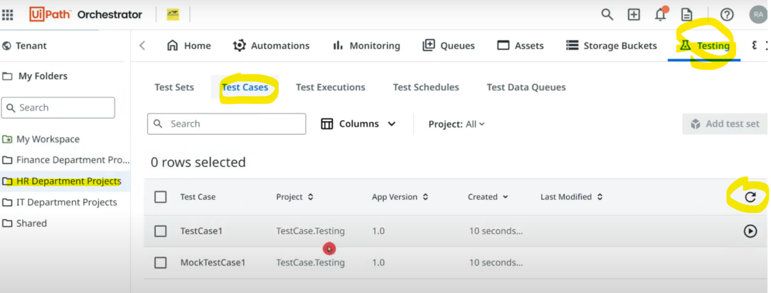

=================================================================================================================================

**Understanding Test Sets in UiPath: Creation and Utilization**

NOTE:

1. Publish test cases (2) from studio
2. Create test set by selecting the published test cases in orchestrator

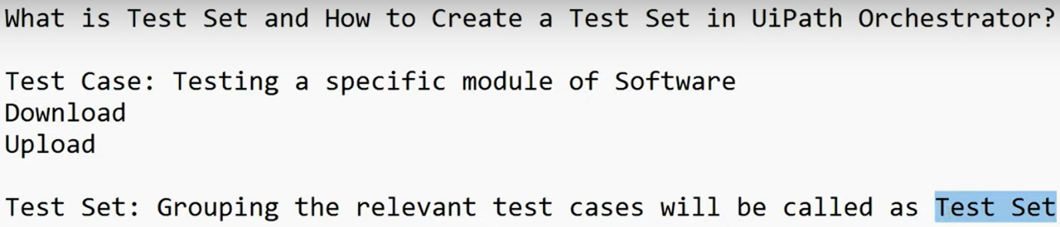

Select the test cases which you want to group as Test set -> right click -> Set as publishable

Click on Publish test cases from studio.

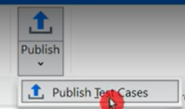

Publish to Orchestrator tenant feed.

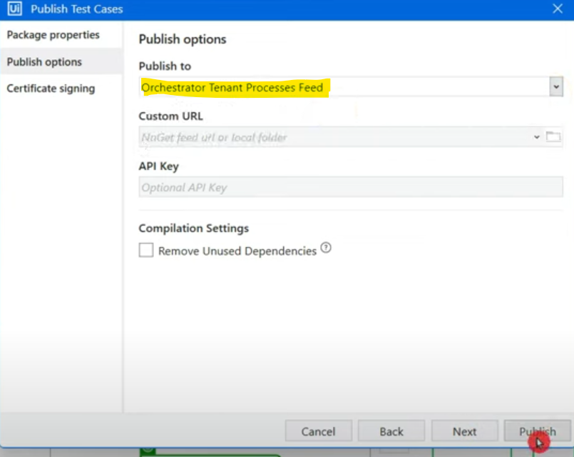

Select test cases & create test set.

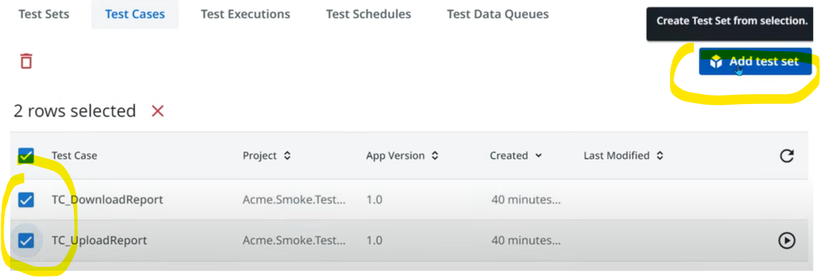

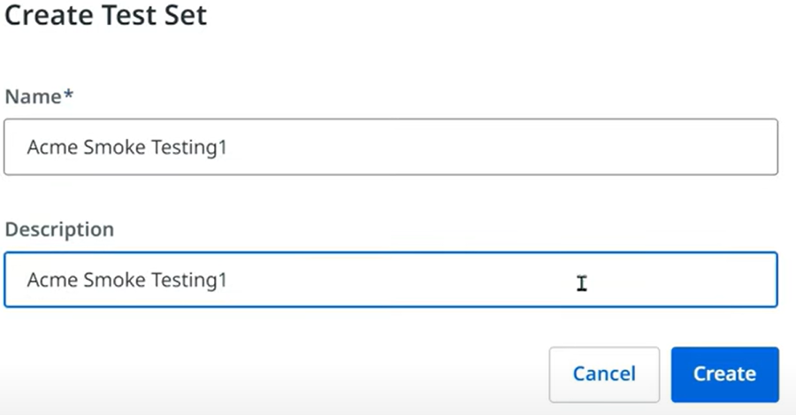

While creating test case I have selected the project under "Select projects" tab.

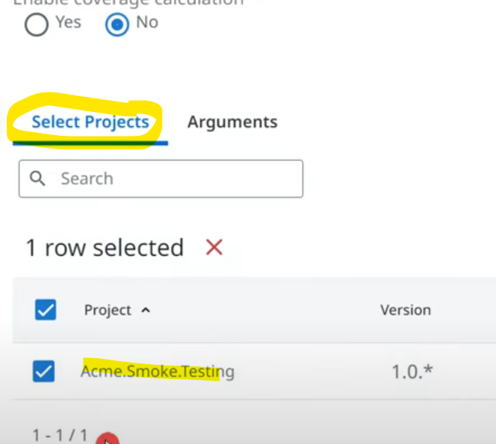

Under "Arguments" tab you can add your arguments which you had in the workflow. Provide default values to start it. But right now we will not update any values as we will use DATA DRIVEN approach in next steps.

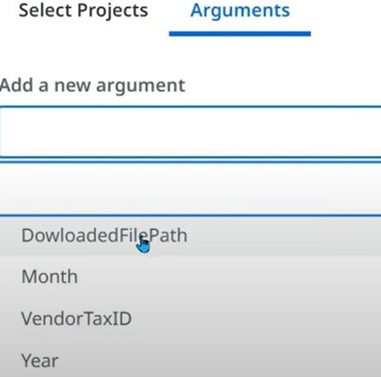

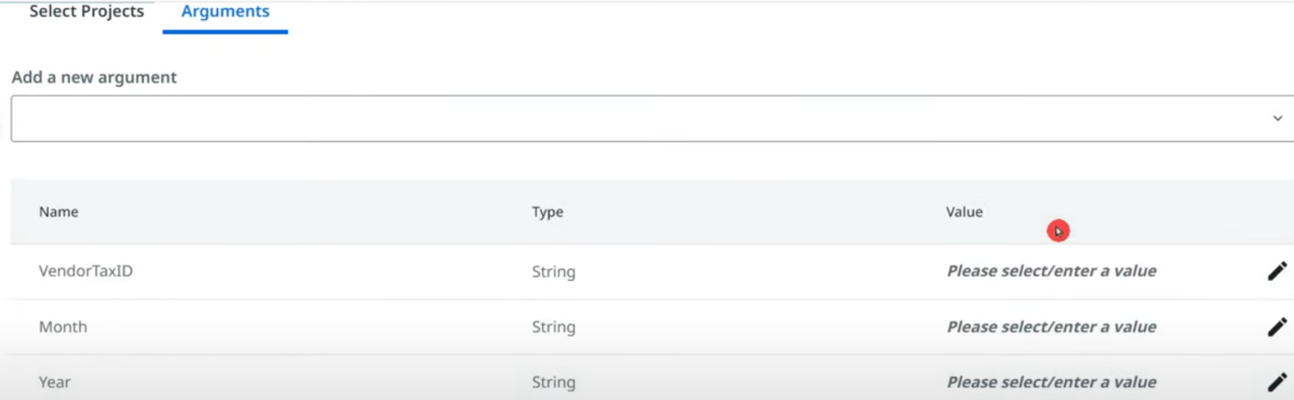

If you execute the test set now, you will see all the data sets you gave during test case creation in the studio.

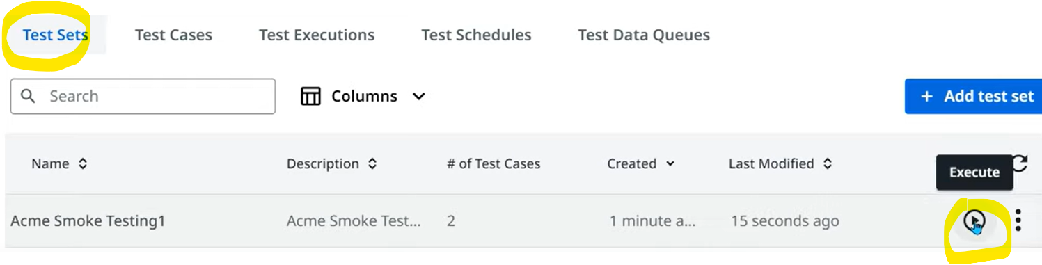

We can see all the data variations we passed earlier & it's execution status.

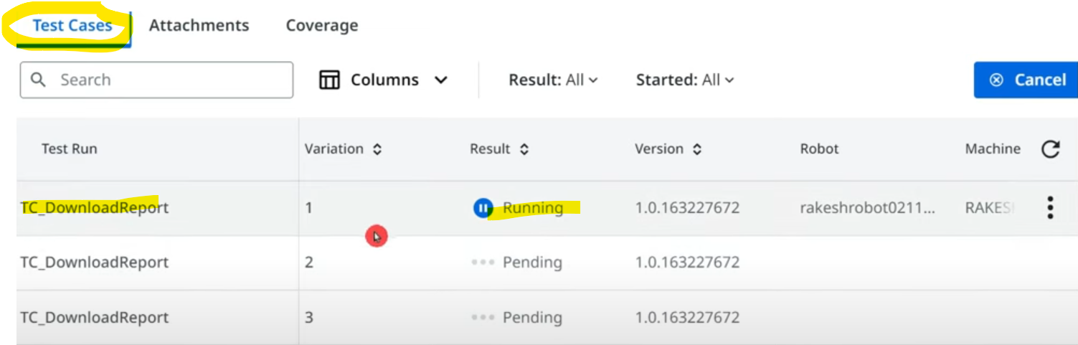

Let's cancel & see what happens.

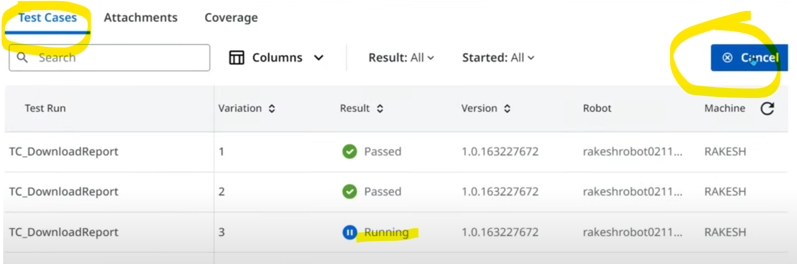

After cancellation it looks like below.

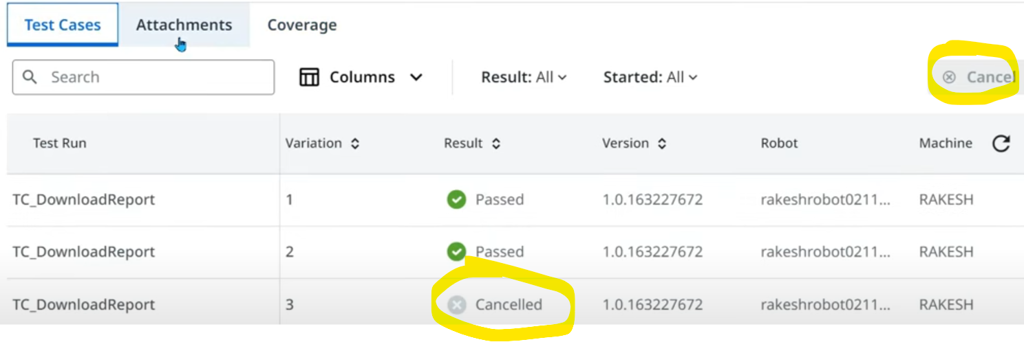

We will be able to see coverage calculation like below.

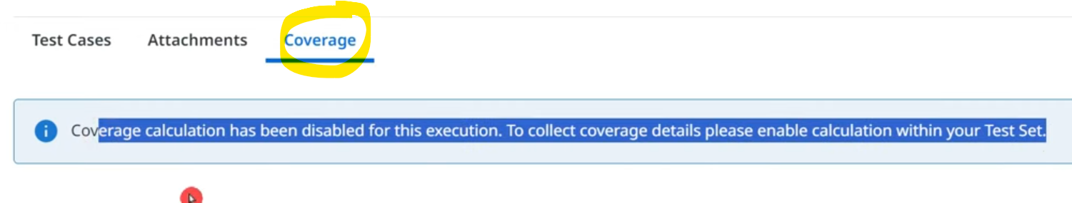

While creating test set, we need to enable this.

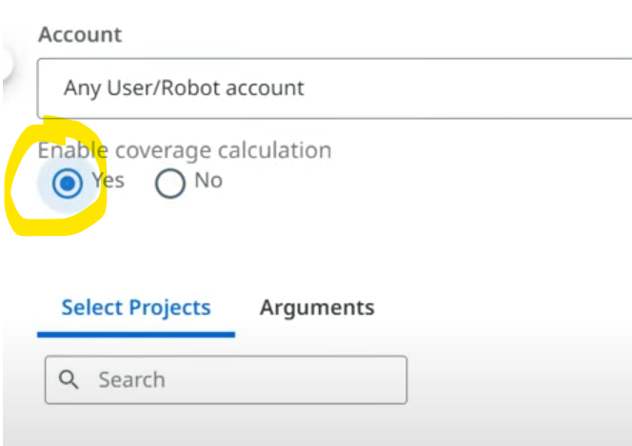

Execute the test set again. It is running.

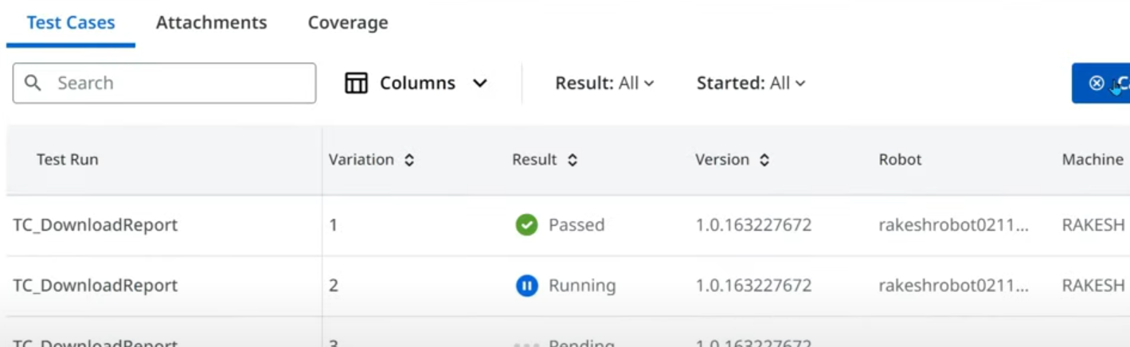

Let's stop & check the coverage.

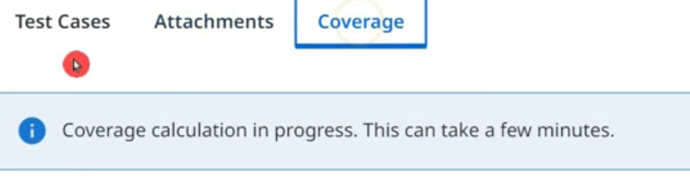

After a minute or so, let's see the test execution tab.

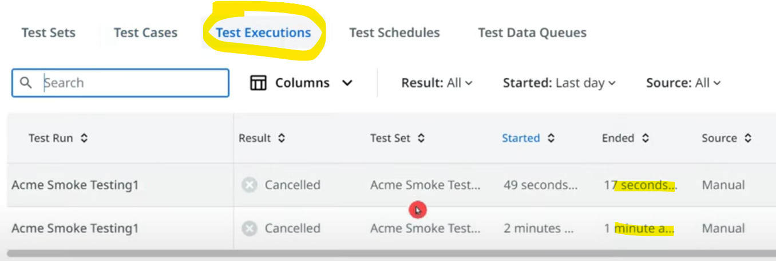

Coverage will be shown like below.

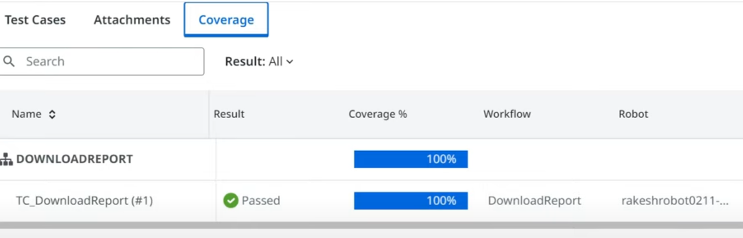

=================================================================================================================================

**Exploring Software Testing Terminology**

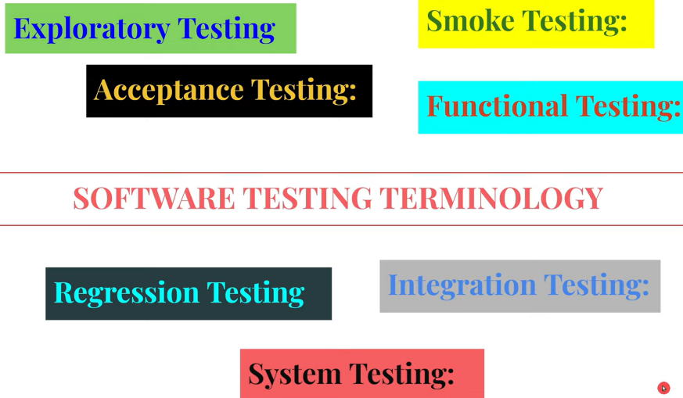

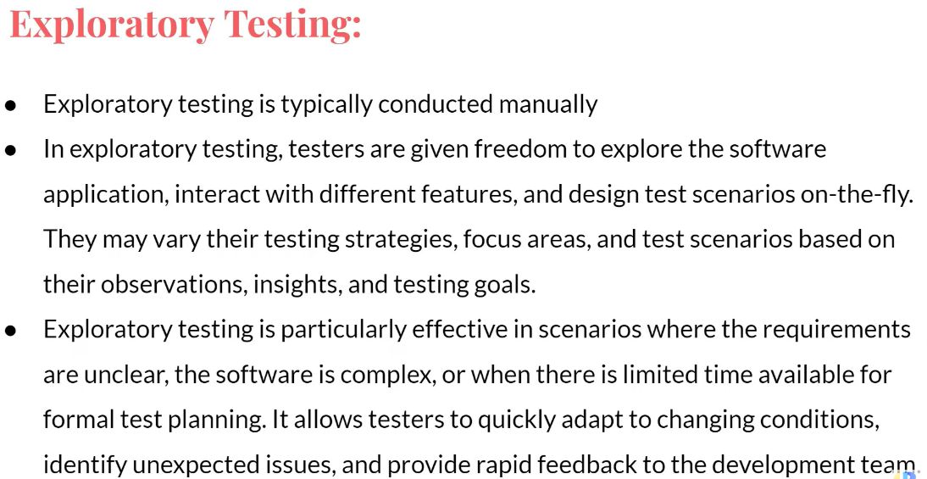

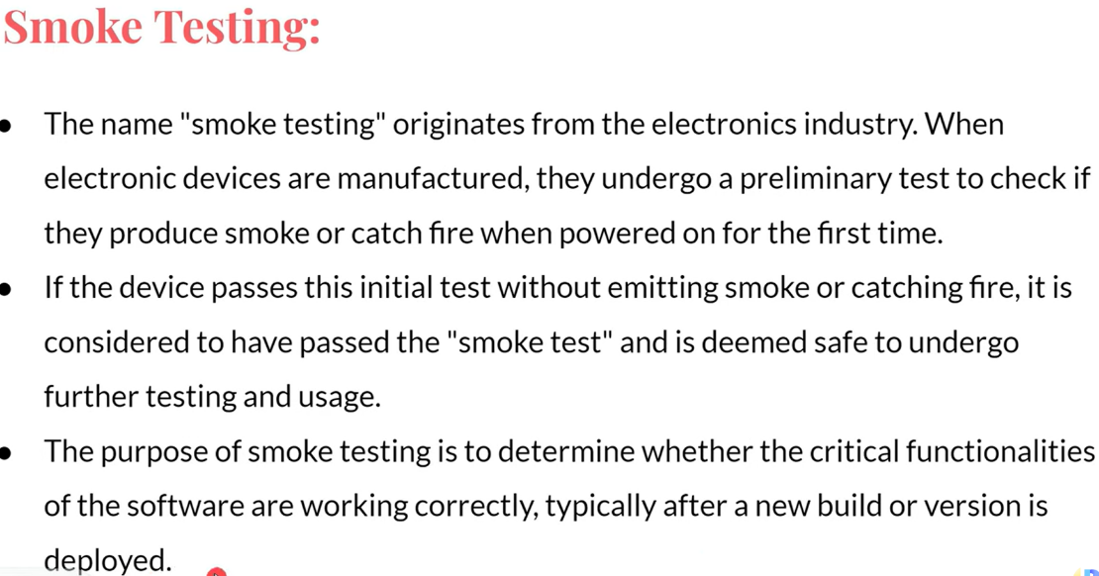

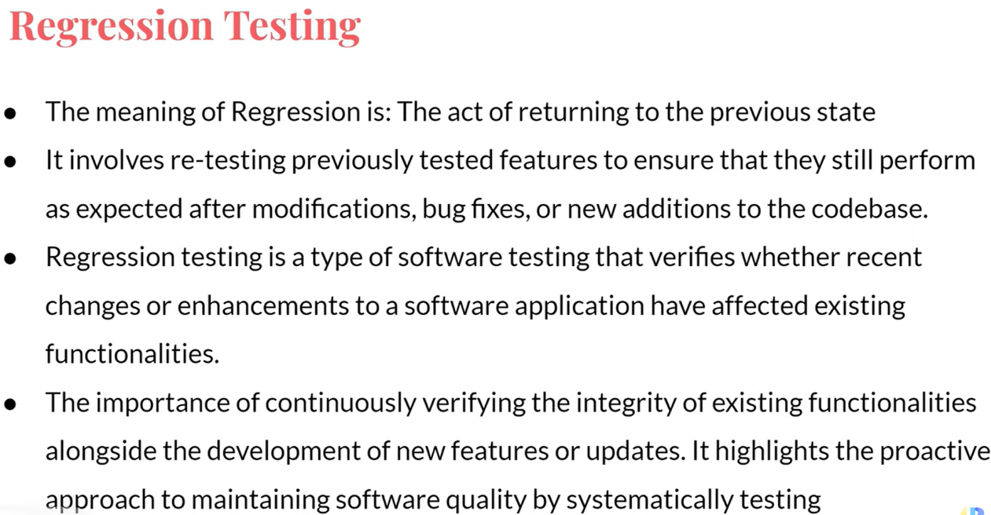

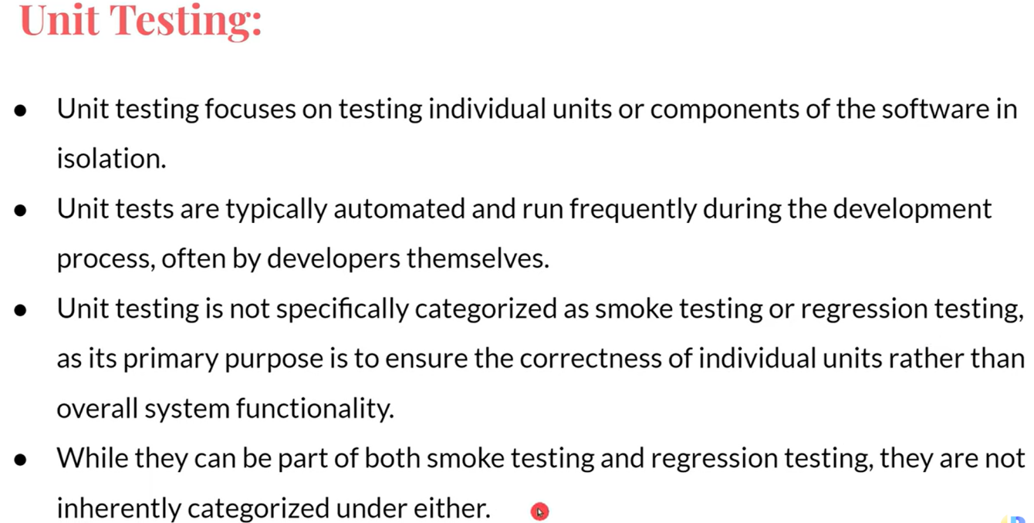

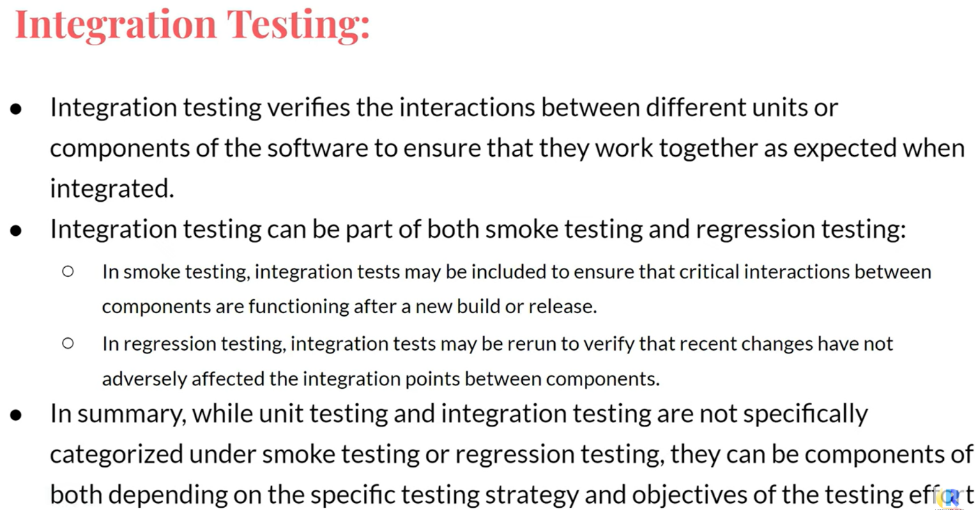

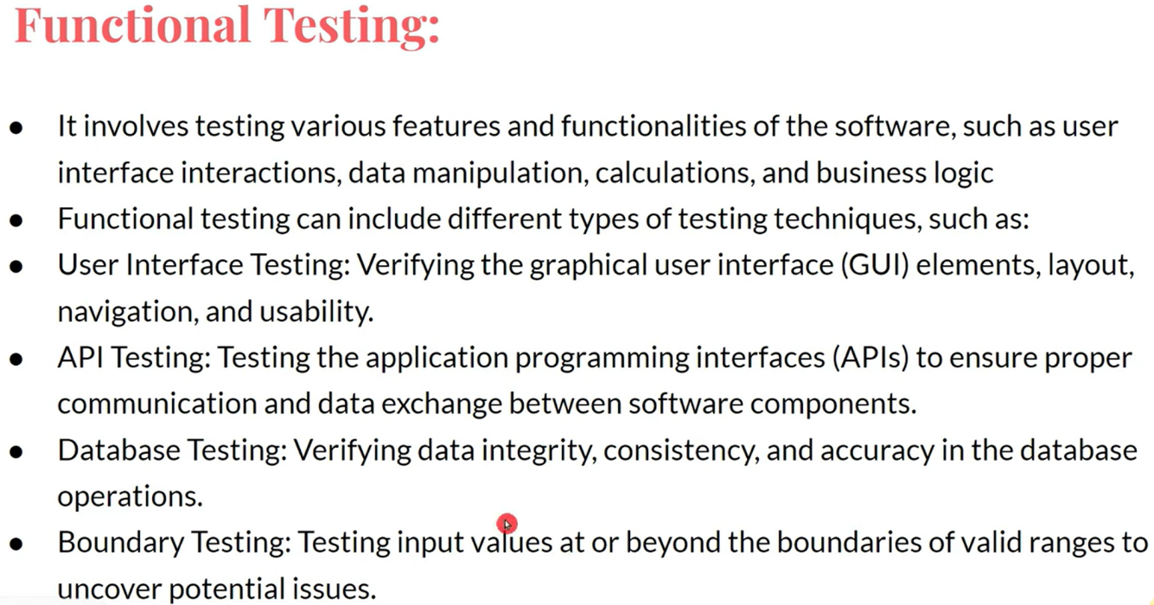

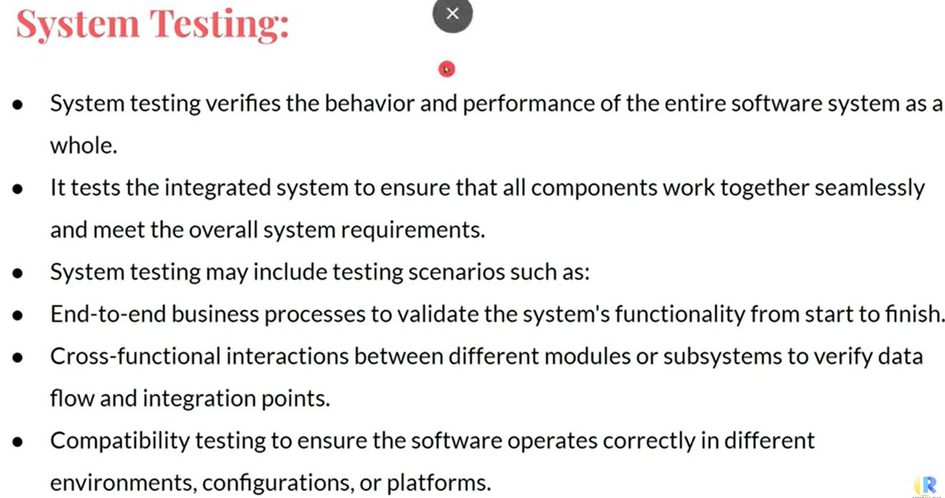

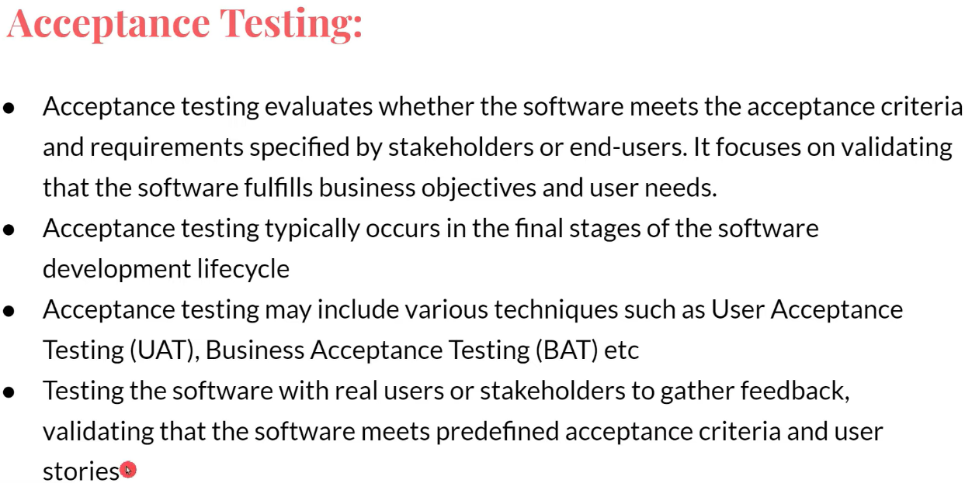

=================================================================================================================================

=================================================================================================================================

=================================================================================================================================

=================================================================================================================================

**UiPath Test Schedules - Orchestrator**

How do you normally execute a test case? Like below.

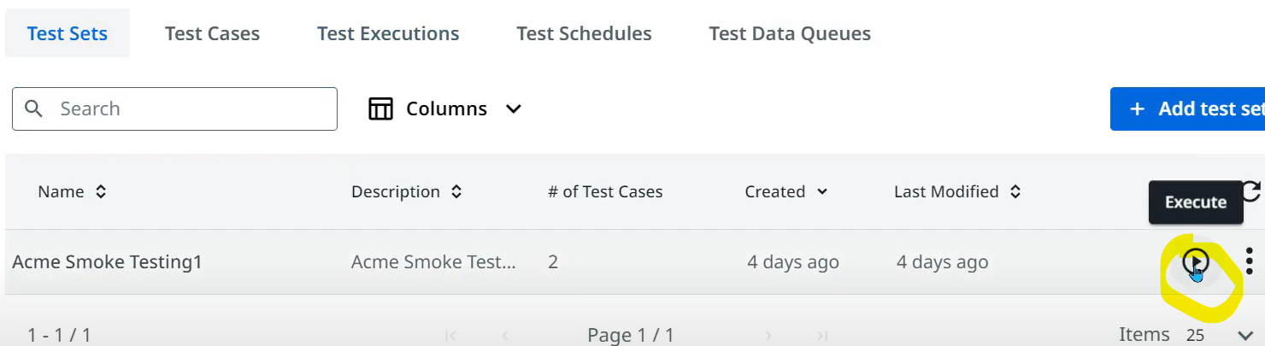

Once execution starts, you can monitor the same in Test executions tab->under 3 dots->Details

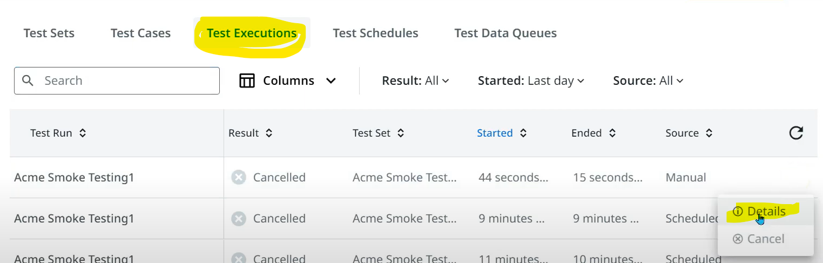

Multiple data to be run in that test case will be shown here.

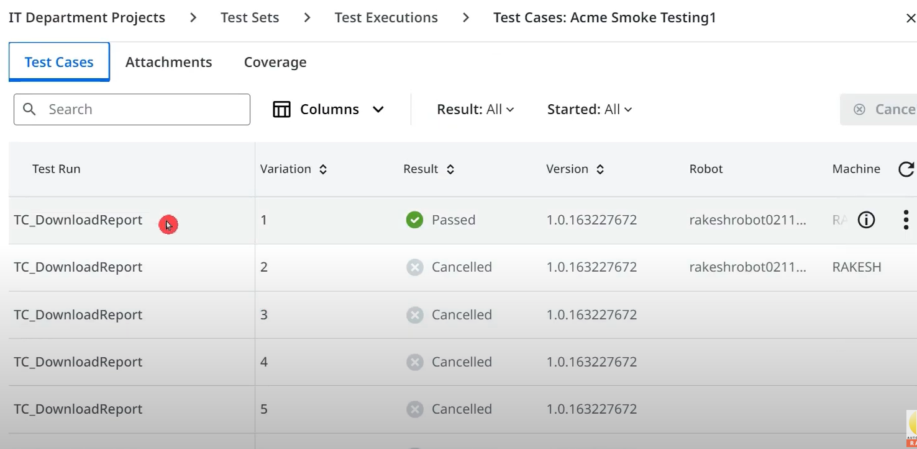

Again if you click on 3 dots -> View assertions. This gives even more detailed info like below.

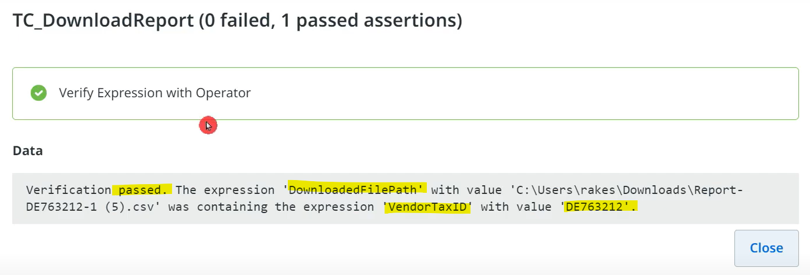

How to schedule these test sets? Navigate to the tab & click on below button.

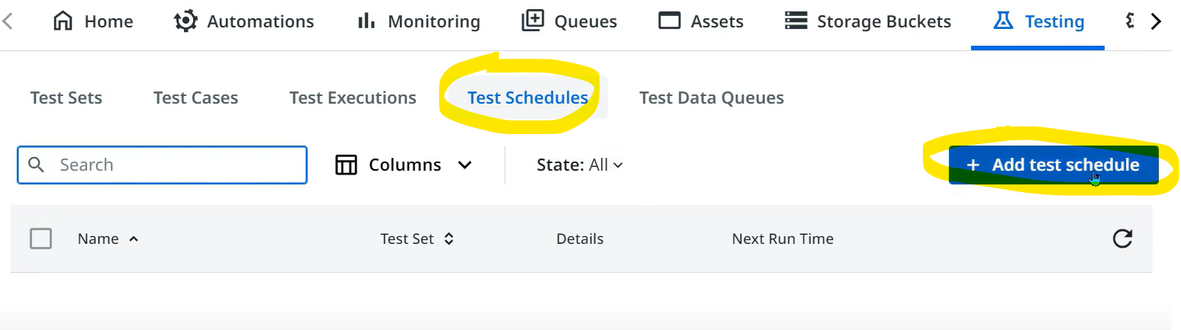

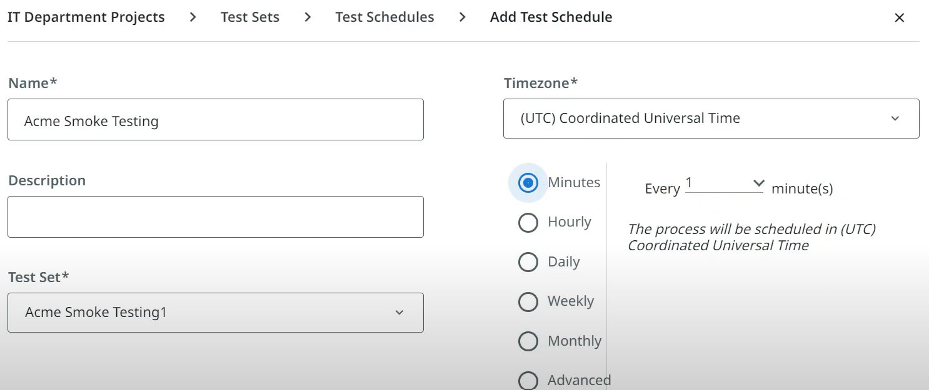

Now we can see the created schedule like below.

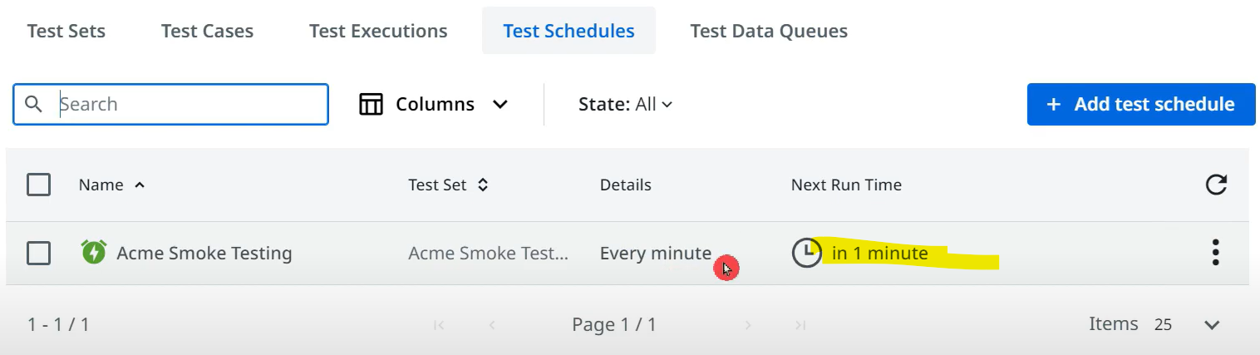

If you keep on refreshing, the highlighted time shows the remaining waiting time for this schedule to run.

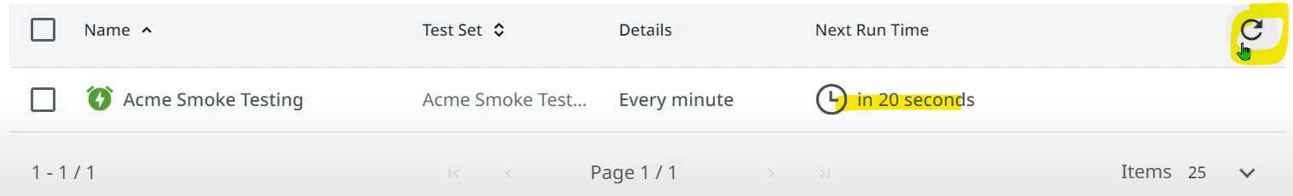

To STOP this, we should go to test execution -> 3 dots -> cancel.